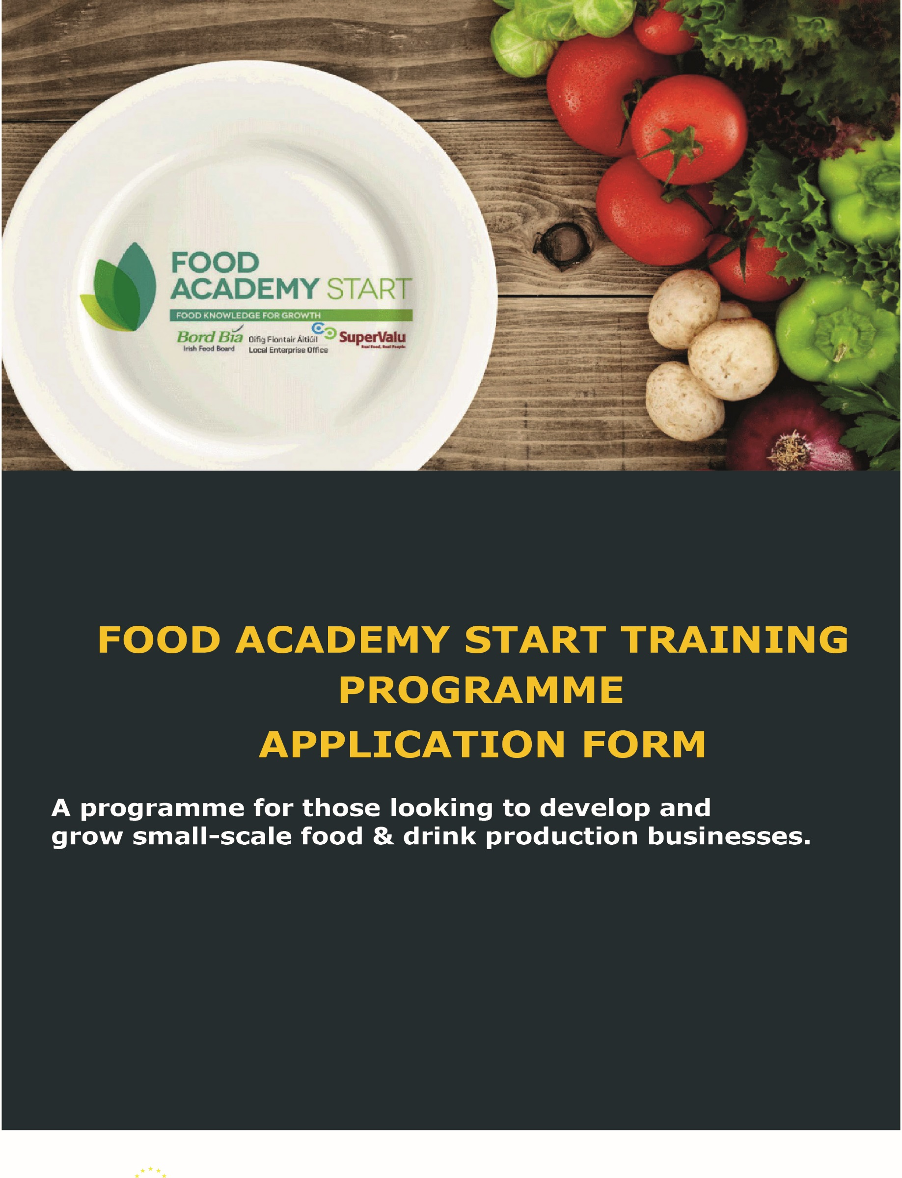

THE FOOD ACADEMY START PROGRAMME
Local Enterprise Offices: Donegal/Sligo/Leitrim
FOOD ACADEMY START
Food Academy is a training programme aimed at supporting and nurturing start-up food businesses. The Local Enterprise Offices have joined forces with Bord Bía and SuperValu on this initiative to provide a consistent level of food marketing knowledge to new and early-stage food business owners.
At the final workshop, participants will get the opportunity to present their product to a panel from SuperValu and if successful, can participate in a trial based in local shops, which in the right circumstances, could progress over time to a national listing with SuperValu. There is no guarantee of your product being listed as part of the programme. However, the majority of products do proceed to trial with Supervalu.

Programme Objectives
- Develop an in-depth knowledge of the tools which can be used to assess market gaps for your product
- Understand core technical issues facing your food or drink business
- Learn how to grow sales for your product range through better branding and packaging design
- Gain all of the tools and knowledge necessary to launch and build a successful food business in Ireland

Who can participate?
The Food Academy is aimed at those in the early to mid-stages of developing a food or drink business. Selection criteria will apply.

How much does it cost?
The Academy cost €150 and is inclusive of all course materials, training and mentoring. If you are pre-approved you will receive a link to make your payment online.

APPLICATION FORM

- PROMOTER DETAILS

Name of Applicant: | Click here to enter text.
Name of Business: | Click here to enter text.
Business Address: | Click here to enter text.
Telephone: | Click here to enter number.
Mobile: | Click here to enter number.
E-mail: | Click here to enter text.
Website: | Click here to enter text.

- BUSINESS DETAILS

Status of Applicant:  (Please tick or shade one only) | Sole Trader ☒ | Partnership ☐
 | Limited Company ☐ | Other ☒ (Please specify)  Click here to enter text.
How long is the business trading: | Click here to enter text.
Current estimated annual turnover: | € Click here to enter number.
How much funding have you allocated to bringing your product to market, please tick/shade one | - Less than €2000 ☐  - €2000 - €5000 ☐  - €5000 - €8000 ☐  - Greater than €8000 ☐

Brief description of your business:
Describe your food or drink product (type of product, number of products in range, weight of the pack of each and the price you will be selling to the customer of each). If you are currently supplying any shops, cafes, etc., list the top 5 outlets you are selling your product through

Click here to enter text.

Description of the market you serve:

Outline results of any Market Research carried out to promote your product e.g. your own customer research, Bord Bia research, etc.
Click here to enter text.

Who and where are your main competitors?

List competitor brands or brands in the nearest similar category to your product?
Click here to enter text.

- Manufacturing
Have you sourced either a suitable food manufacturing premise or a suitable manufacturing option for volume production? Please state where your product is being manufactured (home kitchen, rental incubation kitchen (Named) and if outsourced, to whom?
Click here to enter text.

- EXPERIENCE AND PREVIOUS TRAINING
Please state what if any relevant training programmes you have undertaken:

For example, a Start Your Own Business programme, Food Starter (formerly Kick-Start Your Food Business programme or other
Click here to enter text.

- YOUR GOALS
Explain in a few words what you want to achieve from this programme:
Click here to enter text.

