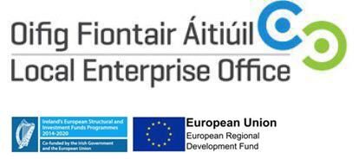

EXPRESSION OF INTEREST FORM
FOR

Lean Business Programme 2019

Please complete this short form….. places will be offered based on suitability to the programme and on a first-come-first-served basis

Please Use Block Capitals

PLEASE COMPLETE ALL QUESTIONS

Your Name: ___________________________________

Business Name: __________________________________
Business Address: ___________________________________
___________________________________
Website: ___________________________________
Business Tel: ___________________________________
Mobile No. ___________________________________
Email: ___________________________________

Please tick as appropriate:

How many years are you running the business? _____________

How many are employed in the business? Full time_______ Part Time _____
Please give a brief description of your business? _______________________________________________________________________________________________________________________________________________________________________________________________________________Have you previously undertaken training with the Local Enterprise Office (or Enterprise Boards)? Yes____ No ____

If Yes, please give details: ____________________________________________________________________
_____________________________________________________________________

What do you hope to achieve by participating in this Programme?
____________________________________________________________________
_____________________________________________________________________
_____________________________________________________________________

Any other information which may be useful -
_____________________________________________________________________
_____________________________________________________________________
_____________________________________________________________________
_____________________________________________________________________
_____________________________________________________________________
_____________________________________________________________________

Please return this completed form to Bernie.moloney@leo.limerick.ie

ALL INFORMATION STRICTLY CONFIDENTIAL

