Ballyhoura Development CLG will deliver a series of Enterprise related workshops during the Months of June and July 2018.
These workshops are designed for those who have a business idea , are in business , are thinking about a new product or service or are interested in applying for the Back to Work Enterprise Allowance
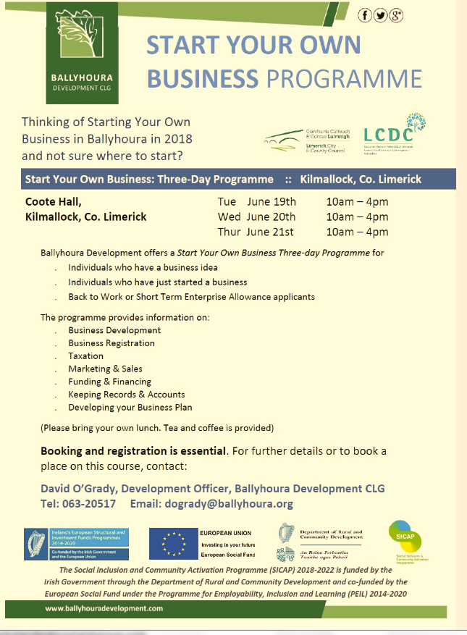
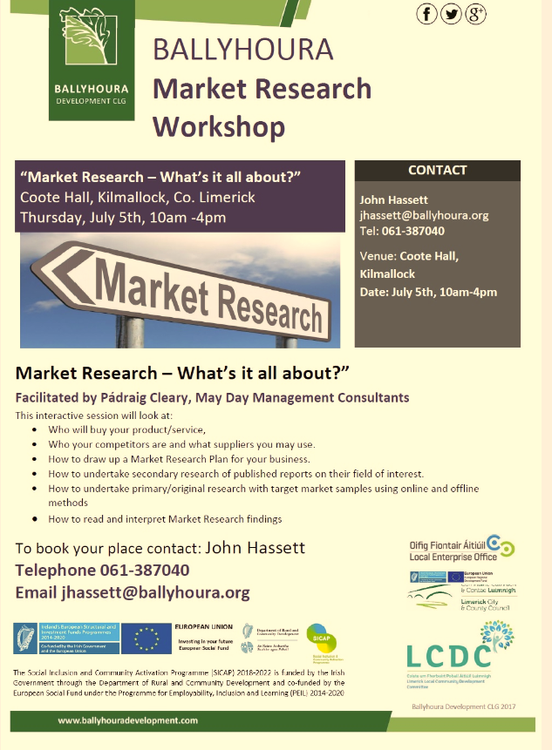
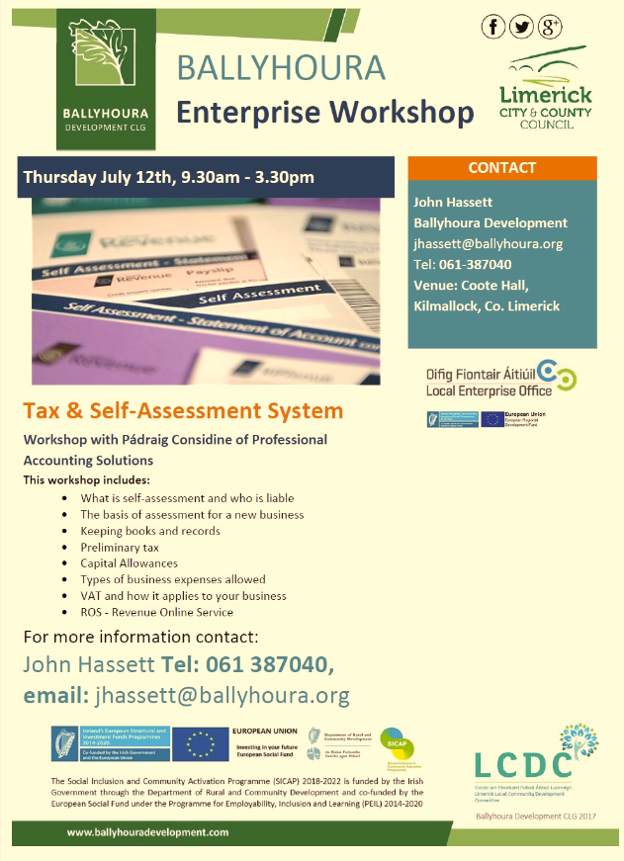

One day One to One Enterprise Clinic to discuss your Business Idea with either Sadie Allen or John Hassett

To book
Sadie Allen
Development Officer
Ballyhoura Development CLG
sallen@ballyhoura.org
025 85213

