Student Programmes Ireland, Limerick Finalist at National Enterprise Awards - 25th May, 2017

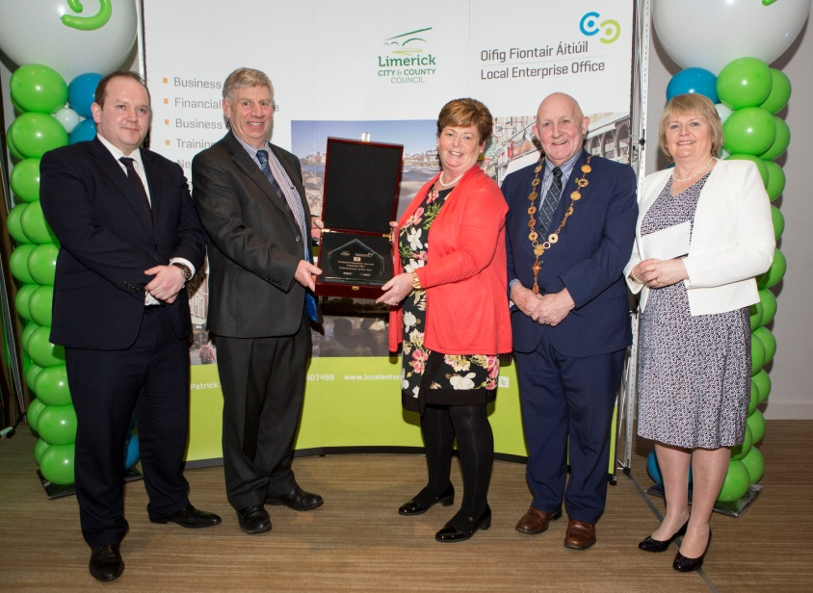

SPIL on “countdown” to National Enterprise Awards Final 2017

Minister Mitchell O’Connor announces names

of all National Enterprise Awards finalists, including the nominee for Local Enterprise Office, Limerick
Student Programmes Ireland Ltd. ( SPIL) representing LEO Limerick, has been officially announced by the Minister for Jobs, Enterprise and Innovation, Mary Mitchell O’ Connor T.D. as a finalist in this year’s National Enterprise Awards.
Organised by the Local Enterprise Offices, the 2017 National Enterprise Awards celebrate the achievements of Ireland’s top small businesses and micro-enterprises from all parts of Ireland in a showcase of enterprise, innovation and ambition at Dublin’s Mansion House on May 25th.
Announcing the finalists, Minister for Jobs, Enterprise and Innovation, Mary Mitchell O’Connor said: “Last week, we saw that Ireland’s unemployment rate has dropped to a new low of 6.2%. This is hugely encouraging, and it is due to the hard work and dedication of enterprise heroes such as these local businesses who are quite rightly taking their place in the spotlight at the National Enterprise Awards on May 25th.”
The Minister added: “These innovative businesses are led by people who are serious about their ambition, who are taking real risks and making real sacrifices to achieve success, and they are making a huge contribution to their local communities and to the economy at large. It is very important that we mark their achievements. I wish all of the finalists the very best of luck in the Final on the 25th May.”
The Limerick finalist Student Programmes Ireland Ltd is an award winning company based in Charleville, Cork, Ireland and was set up in 2009 to cater for the increased demand for international students to come to Ireland to improve their English Language Learning Skills.
The staff of Student Programmes Ireland have many years of experience in dealing with international students from a variety of homestay programmes to academic year programs.
The company will be represented at the National Enterprise Awards on May 25th by Bernie Carroll
The other finalists this year are drawn from diverse business sectors, such as skincare, ice-cream making, language courses and mobile game development. The announcement of finalists was made at the Mansion House by Minister Mitchell O’ Connor, accompanied by Sheelagh Daly and Oisín Geoghegan representing the Local Enterprise Offices, Brendan Flood of Enterprise Ireland and last year’s Overall Winner, Mark Clendennen of Applied Concepts in Offaly.
Local Enterprise Office, Limerick, who will be represented in the Mansion House by Bernie Moloney, said: “Small business and micro-enterprises, including SPIL, are making an outstanding contribution to our local economy. Last year, nearly 3,700 new jobs were created by over 6,800 micro-enterprises supported by LEOs all over the country. These entrepreneurs are continuously looking to grow by developing new products and services and investing in export markets. The National Enterprise Awards help to recognise the contribution that small businesses and micro-enterprises make to our communities every day.”
Last year’s winner, Applied Concepts in Birr, manufacture and export blast machines used in construction and renovation projects in countries such as Spain, Denmark and Chile.
Previous winners nationally have also included Irish Yoghurts, Innovate, Grouse Recording Studios, Simtech Aviation, MyBio and Design Pro.
The winners of this year’s National Enterprise Awards will be announced at the Mansion House in Dublin on Thursday, May 25th. Twelve Awards will be presented including eight Regional Awards. The overall winner will receive €10,000 to invest in their business.
Competition updates and results will be available through www.localenterprise.ie and by following #NEAwards on social media.
The Local Enterprise Offices are co-funded by the Irish Government and the European Regional Development Fund 2014-2020.

NATIONAL FINALISTS IN 2017 (supported by their Local Enterprise Office)
LEO Area & Company Website
Carlow McNally Denture Clinic www.mcnallydentureclinic.ie
Cavan Moran’s Megajam Ltd www.moranshomestore.com
Clare Core Optimisation Ltd www.coreoptimisation.com
Cork (City) Rebel Chilli www.rebelchilli.com
Cork (North & West) Enibas Jewellery www.enibas.com
Cork (South) Polar IceTech www.polaricetech.ie

Donegal
Sharon McDaid – Silver Birch Gallery & Studio www.sharonmcdaid.com
Dublin (City) Pink Kong Studios www.pinkkongstudios.ie
Dublin (DLR) Moontour www.moontour.ie
Dublin (Fingal) Hope Beer www.hopebeer.ie
Dublin (South) Acutrace www.acutrace.com
Galway (City) 9th Impact www.9thimpact.com
Galway (County)IMS Marketing www.imsmarketing.ie
Kerry Irish Host Family Ltd www.irishhostfamily.ie
Kildare Broghies Ireland www.broghiesireland.com
Kilkenny Greensbridge Engineering Ltd www.greensbridge.ie
Laois Infrastruct AMS Limited www.infrastruct.ie
Leitrim Jinny’s Bakery www.jinnysbakery.com
Limerick Student Programmes Ireland Ltd www.spil.ie
Longford Purpledecks Ltd. www.purpledecks.com
Louth Aphix Software Ltd www.aphixsoftware.com
Mayo Monaghan Bros Bar Furniture Manufacturers Ltd www.barfurniture.net
Meath Hexafly www.hexafly.co
Monaghan RAMfit Ltd www.ramfit.com
Offaly Dezynamite www.dezynamite.com
Roscommon PJ Fallon & Son www.pjfallon.ie
Sligo Studyclix www.studyclix.ie
Tipperary MediSkin www.mediskin.ie
Waterford Pip and Pear Chilled Baby Food www.pipandpear.ie
Westmeath Lift Hire Ireland www.lifthireireland.com
Wexford Scup Gelato www.scupgelato.com
Wicklow Goldfish.ie www.goldfish.ie

Award Categories and Prize Fund – National Enterprise Awards 2017
- Overall Winner, National Enterprise Awards 2017 (Cash Prize for business: €10,000)
- Best Export Business(Cash Prize for business: €5,000)
- Best Start Up Business (Cash Prize for business: €5,000)
- Innovation Award (Cash Prize for business: €5,000)
- Eight Regional Winners (Cash Prize for business: €2,000 each)

Regions:
  - Dublin City, Fingal, Dún Laoghaire- Rathdown and South Dublin
  - Kildare, Laois, Offaly and Westmeath
  - Wicklow, Wexford, Carlow and Kilkenny
  - Louth, Meath, Cavan and Monaghan
  - Donegal, Sligo, Leitrim and Longford
  - Galway, Mayo and Roscommon
  - Clare, Limerick, Kerry and Tipperary
  - Cork City, South Cork, Cork North & West and Waterford

Local Enterprise Offices (LEOs)
As part of a range of reforms carried out by the Department of Jobs, Enterprise and Innovation (DJEI) in recent years, the 31 Local Enterprise Offices (LEOs) were established to provide a ‘first-stop shop’ system of enterprise supports to start-ups and small businesses across the country. Located in the Local Authorities, the LEOs are operated on a partnership basis by Enterprise Ireland and the Local Authorities and their parent Departments, DJEI and the Department of Housing, Planning and Local Government. The LEOs provide funding for projects primarily in the manufacturing and internationally traded services sector which over time have the potential to develop into strong export entities. There are three main categories of grant under which direct financial assistance is provided – Priming, Feasibility and Business Expansion. The LEOs also provide training and mentoring support to entrepreneurs and businesses to assist business development and performance. Details on all the supports available for small businesses and micro-enterprises through all LEOs are available at www.localenterprise.ie.

