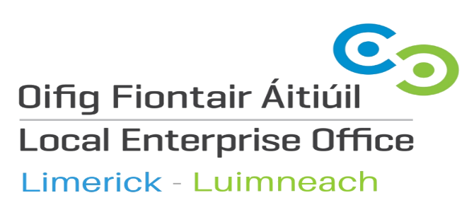

Expression of Interest 2021

Membership of the Evaluation and Approvals Committee of the Local Enterprise Office (LEO) Limerick

Public call for expression of interest for individuals to serve on
Evaluation and Approvals Committee (EVAC) of the
Local Enterprise Office (LEO) Limerick
The Local Enterprise Office (LEO) Limerick, part of Limerick City and County Council, is a first stop shop to provide support and services to help start, grow and develop micro and small businesses in Limerick City and County. The Evaluation and Approvals Committee (EVAC) evaluate all projects being considered for financial support.
Limerick City and County Council is now inviting expressions of interest from individuals who consider themselves to have the necessary interest, expertise and experience to be appointed to the Evaluation and Approvals Committee. There is no remuneration attached to the positions.
Prospective members should have:
- Extensive experience in assessing financial and business proposals and the ability to challenge company submissions;
- Broad business experience and a clear ability to empathise with challenges facing micro enterprises;
- The ability to demonstrate their understanding and experience in the micro enterprise sector;
- Expertise in one of the following areas:
  - Debt/banking/cash-flow management expertise
  - Equity/investment expertise
  - Financial and/or business qualifications
  - Business Development
  - Marketing/sales
In making any appointments to this Committee, the Local Authority will give due consideration to the principles of equality and gender balance; however the Council will not necessarily be confined to those who make such expressions of interest but will ensure that all of those appointed have the relevant mix of knowledge and expertise to contribute to the Committee.
Limerick City and County Council will appoint members for a maximum period of five years. The decision of the Council is final and is not confined to the applications received. All expressions of interest lapse at the end of two calendar years from 26th February 2021.
Completed expression of interest forms should be sent to localenterprise@limerick.ie by e-mail by 4.00 p.m. on Friday 26th of February 2021.
All applications will be acknowledged and applicants will be informed in due course of decisions in relation to the appointments.
First name:
Surname:
Contact Number:
E-mail:
Address:
Social Media Profiles (optional):

Areas of Interest | Please mark (x) in appropriate boxes
Entrepreneurship ☐ Business Development ☐

Management of debt; banking; ☒ Marketing and Sales ☐
cash-flow

Equity and Investment ☐

Areas of Expertise | Please mark (x) in appropriate boxes
Entrepreneurship ☐ Business Development ☐

Management of debt; banking; ☐ Marketing and Sales ☐
cash-flow

Equity and Investment ☐

Short summary of work experience (organisation, years, position/types of work):

Experience in assessing financial proposals:

Short description of the skills set that you will bring to the Committee:

Any specific examples that demonstrate your expertise in any of the above mentioned fields:

A short statement outlining your reasons why you wish to serve on the Committee:

You are welcome to attach your CV to this application if you wish.
Please return this form by e-mail to localenterprise@limerick.ie by Friday 26th February 2021 at 4.00 p.m. with the subject line ‘EoI EVAC Committee.’

Thank you for your expression of interest.

