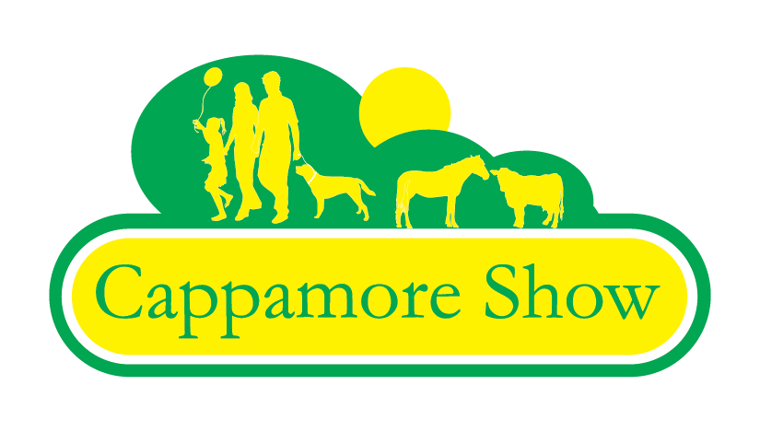
19th August 2017
“Limerick Food Experience”
Expression of Interest Form
Name:__________________________________ Mobile Number _____________
Business name: ________________________________ Email ________________
Business Address: ___________________________________________________
Website address: ___________________________________________________
Position of Applicant in the Business:______________________________________
Food Category i.e. Dairy, Confectionary:___________________________________
Details of Product Range:______________________________________________
_________________________________________________________________

Brief Description of your company:_______________________________________
__________________________________________________________________
Date of Business Start-up: ______________________________________________
Have you participated in similar shows in the past? If yes please give details: __________________________________________________________________
__________________________________________________________________
__________________________________________________________________
Please note: A €60 fee will apply if your application is successful.
Closing Date for Applications is Friday 26th May 2017.

