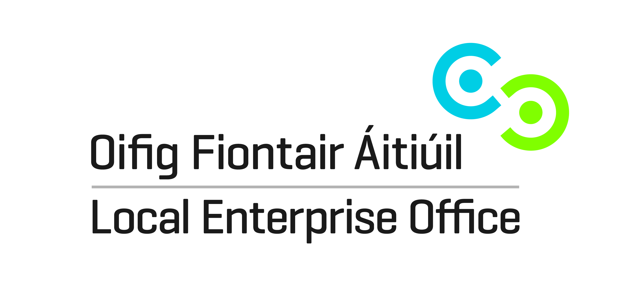
Digital Media in your Business
Intermediate Programme –Autumn 2014
Expression of Interest Form

Name:__________________________________ Mobile Number ___________________
Business name: ________________________________ Email _________________
Business Address: __________________________________________________________
Position of Applicant in the Business:____________________________________________
Date of Business Start-up: ____________________________________________________
I wish to do this course commencing 24th September 2014 and finishing 12th November 2014 because ____________________________________________________________________________________________________________________________________________________________________
Signed: __________________________ Date: ____________________
Do not include payment until your place on this course has been confirmed to you.
Please note: Participants must already using some elements of Social Media in their business As well as their website. This course is suitable as an advancement/refresher for those who may already have completed previous programmes given by LCEB. Participants will be required to have their own laptops during this course. Laptops will connect to a wireless connection for Internet access. It is up to the participants to look after the technical setup of their laptops.
Please forward all enquiries & bookings to Heather at bernie.moloney@leo.limerick.ie (Only one place per company – must be small business (10 people or less) owners or managers)


