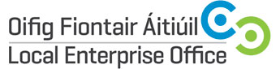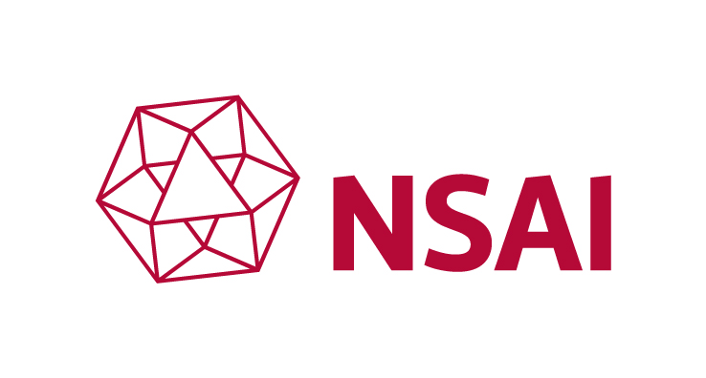



Sector Information & Advice Workshops in
I.S. EN 1090-1 Requirements for conformity assessment of structural components

Mid West Regional Workshop
Limerick – Thursday 5th March 2015

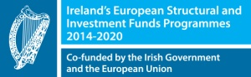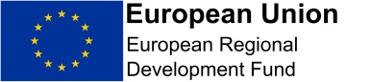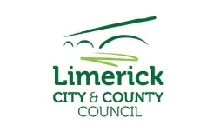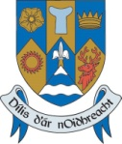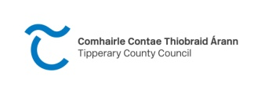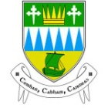

The Local Enterprise Offices in association with the National Standards Authority of Ireland is hosting a series of seminars across Ireland for Fabrication, Engineering , construction companies and interested parties in the Harmonised European Standards which now is a mandatory requirement under EU regulations. This standard is of competitive importance to relevant companies and this seminar aims to explain the process of certification and also outline possible supports available from your Local Enterprise Office in order to achieve certification.

The seminar will be delivered by Sean Balfe , Director of Sustainability and Built Environment who is the industry expert with the NSAI and cover:

- Construction Products Regulations and Register.
- Requirements for conformity assessment of structural components EN 1090 Impact on Typical Fabrication Company What products are or not covered in the Regulation and Standard. CPR 07/40/3
- How to get certified.
- NSAI’role in this process as the Notified Body

The programme for the seminar is as follows:

6.30pm Registration & Refreshments
7.10pm Sean Balfe
Director of Sustainability and Built Environment - NSAI
7.40pm Supports available from your Local Enterprise Office
8.00pm Q & A
8.30pm Close

Limerick Date: Thursday 5th March 2015
Time: 6pm-8.30pm (Refreshments Available from 6.30pm)
Venue: Dunraven Arms Hotel Adare, Conference Centre
To Book www.localenterprise.ie/limerick or call Heather 061 407499
Fee: Free of Charge

