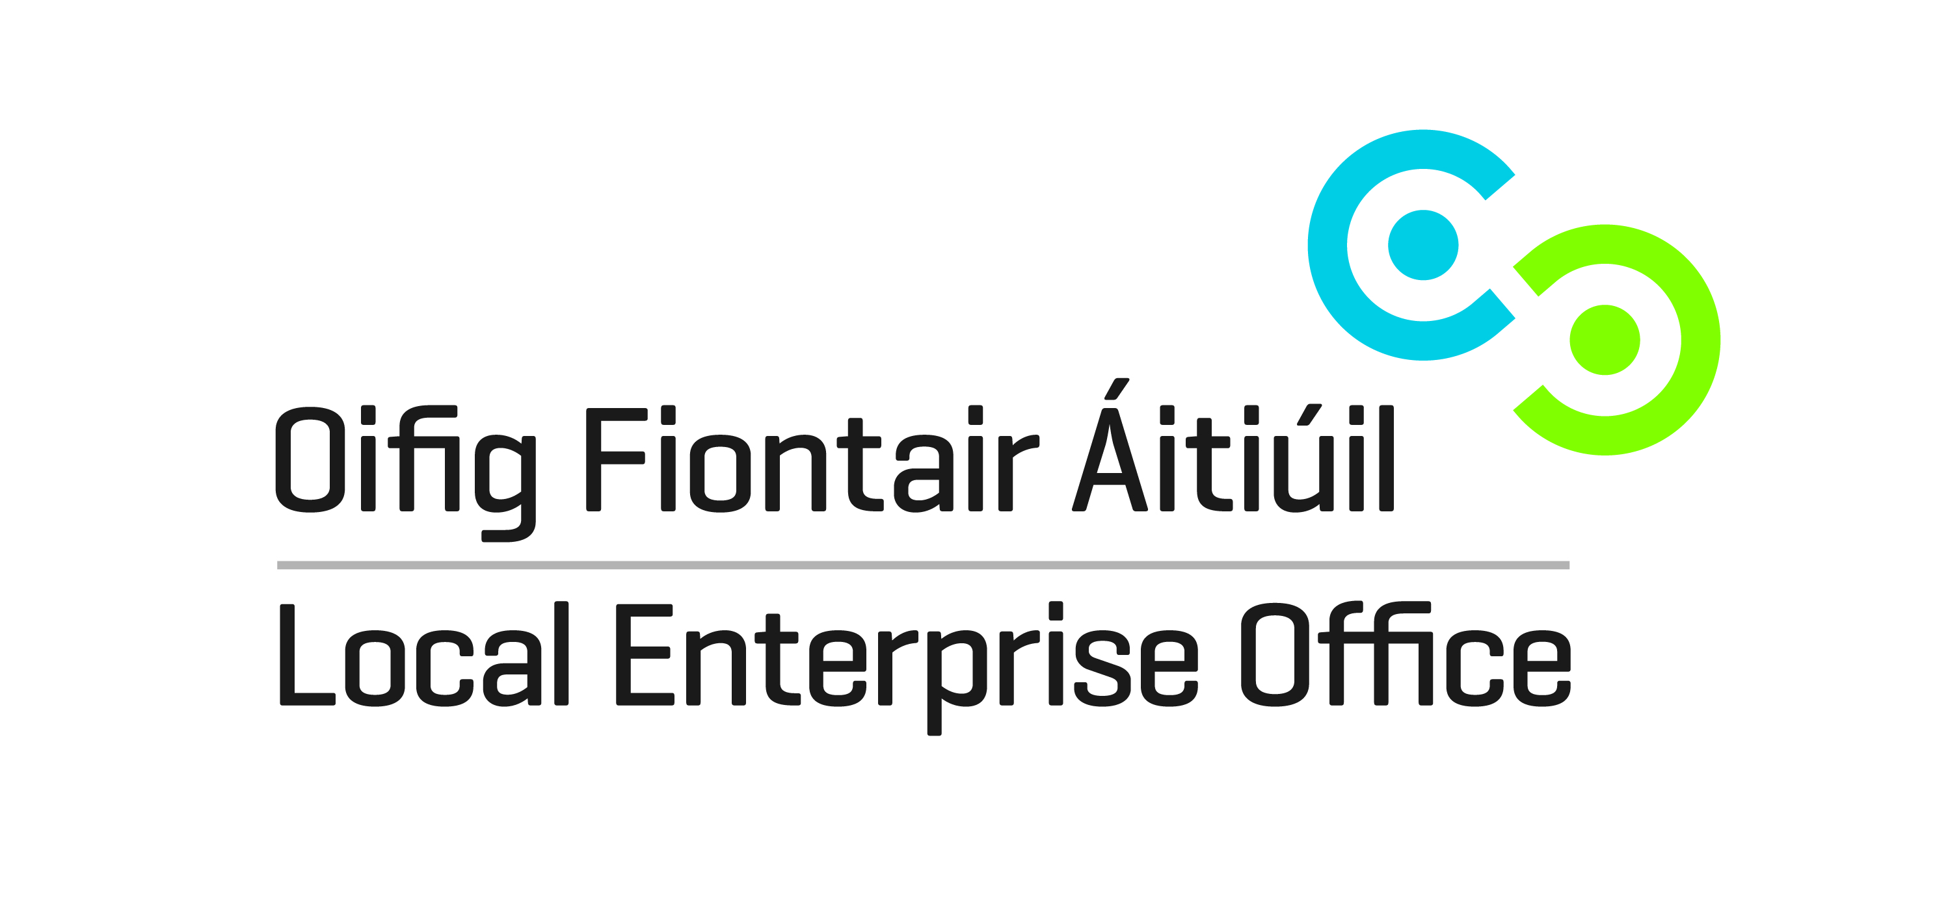
Start Your Own Business Programme

Workshop 1 Key success factors for Start Ups Monday 20th October

Self Assessment

Workshop 2 Preparing a business plan Monday November 3rd

Workshop 3 Researching the Market Monday November 10th

Workshop 4 Marketing Monday November 17th

Workshop 5 Legal & Taxation issues for Start-Ups Monday November 24th

Workshop 6 Running a small business Monday December 1st
Financial Issue Funding Bookkeeping

Target Participant : This Activity Based Learning Programme is designed for those with a specific business idea in mind, either just started or about to start their own business.
Aim: Over six sessions, each participant will explore their own business idea using a structured business planning framework.
Outcome Participants will have a first draft Business Plan with specific recommendations to develop the Business Plan further.
One to One : Each participant will be allocated 1 x 60 minute mentor session to review specific issues faced by the participant and to provide specific recommendations on how the business plan and the business can be developed further.
Details Time: 7-10pm
Venue: Kilmurray Lodge
Cost: €80 waged €40 unemployed

Please note this course is highly subsidized full cost per participant is €400

Numbers are limited. Places allocated to eligible applicants on a first come, first served basis.
Application Form & further information contact: heather.supple@ leo.limerick.ie or call 061-407-499. Booking online www.localenterprise.ie/limerick

