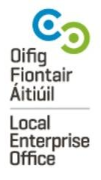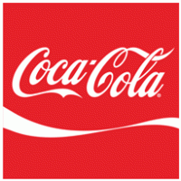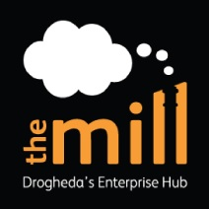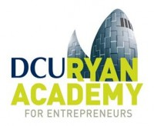

Application Form

Boyne Valley /M1 Female Entrepreneurship Programme
Please forward applications to admin@themilldrogheda.ie by December 16th. Successful applicants will be informed on January 13th.
- Applicant’s name_______________________________ Phone number: _________________
- Email: ________________________________
- Company Name:__________________________________
- Company website: __________________________________
- Company Address: ___________________________________________________________
- Tell us what your (potential) business does in one line:
_____________________________________________________________________________
- What is your ambition for the business?
______________________________________________________________________________
______________________________________________________________________________
______________________________________________________________________________
- Have you been approved for investment by LEO/Enterprise Ireland?
______________________________________________________________________________
- How much (if any) has been invested in the business to date? ________________________
- Have you previously participated on an accelerator or incubator- if so, please name them and when you attended?
_______________________________________________________________________________
- Has your company won any Business awards? ____________________________________
_________________________________________________________________________
- How did you hear about the Boyne Valley Female Entrepreneurship Programme?
__________________________________________________________________
Market
- Who are your target customers? What competitive alternatives are available to your target customers? Can you quantify what the market opportunity will be in 3 years’ time - and how have you derived that market size?
__________________________________________________________________________
__________________________________________________________________________
__________________________________________________________________________
__________________________________________________________________________
- Do you plan to export? ___________________
To what markets? ____________________________________________________________
- What do you aspire to achieve in the next 12 months?
____________________________________________________________________________
- What do you expect to gain from participation on the Female Entrepreneurship Programme 2017? Areas of help?
__________________________________________________________________________________________________________________________________________________________________
___________________________________________________________________________________________________________________________________________________________________________________________________________________________________________________

