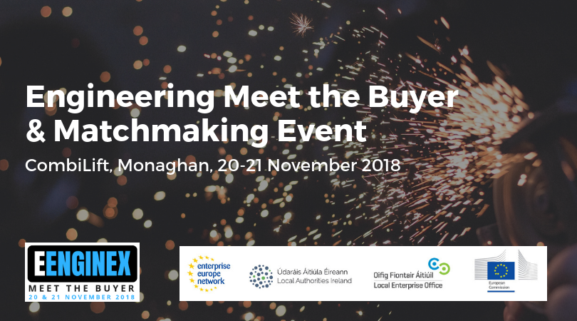

Breaking into new markets and making contact with the right buyers in the right organisations can be a difficult and a time consuming process. EENGINEX simplifies this process by bridging the gap between buyer and supplier. This event format offers you a unique opportunity to engage in a series of pre-arranged, face-to-face sales meetings with senior buyers from throughout Ireland and the EU.

EENGINEX is being run over two days at the new, state of the art CombiLift factory complex in Monaghan, where you will be given an opportunity to participate in a series of talks and factory tours, before engaging in pre-arranged meetings with a variety of senior engineering buyers from throughout Ireland and the EU.
It is expected that in excess of 30 engineering buyers, and 150 supplier companies, will attend the event, and we would be delighted if you could join us for what promises to be an unrivalled opportunity to grow your business.

Target group
EENGINEX is targeted at participants from the following industries:
- Mechanical Engineering  - Industrial tooling  - Materials Handling  - Materials and components | - Marine  - Aviation and Aerospace  - Electronic Engineering  - Precision Engineering

Why participate?
- Grow Your Sales
- Initiate contacts for commercial, technology or R&D co-operation
- Develop your business network
- Share your experience, knowledge and expertise with participating companies
- Present, discuss and develop new project ideas
- Keep an eye on market trends and identify technology innovations

Workshop Topics
- Applying the Principles of Lean Manufacturing to Engineering
- Readying Your Business for Brexit
- Family Succession – Future Proofing Your Business
- CombiLift – Training Case Study
- Making an Impact with Buyers at an Meet The Buyer event

Matchmaking
EENGINEX is an ideal opportunity to initiate promising contacts through pre-arranged meetings.

How does it work?
1. Register online & provide details on what you expect to get from the meetings.
2. Browse the participant list and book meetings with buyers and other participants of interest.
3. Before the event, you will receive your personal individual meeting schedule.

How it Works
A Meet the Buyer event is a quick and easy way to meet potential buyers (and suppliers). Having received your appointment schedule and buyer information in advance, you then attend a one-to-one meeting of 15 minutes duration. When the bell rings, you promptly move on to your next meeting as set out in your schedule.
Timelines | Task | Description
Until 2 November | Registration and Completion of Your Company Profile | - Register at http://www.b2fair.com/eenginex2018/  - Complete your company profile. The better your profile the more meeting requests you are likely to receive.
September to 2nd November | Book B2B meetings  Matchmaking | - We will send meeting requests to selected buyers of your choice  - As buyer slots are limited, meeting requests are reviewed by EENGINEX to ensure relevance and quality  - Matchmaking then takes place
16 November | Your Meeting Schedule | - You receive your provisional meeting schedule by email
21 November | Face-2-face meetings | - You receive your updated schedule and information pack at the Sign-in Desk  - Your schedule contains time and table number of each meeting
This event has limited places, so register early to avoid disappointment.
Unlike other matchmaking events, EENGINEX is not operated on a "first come - first served" basis; as buyers are limited to a maximum number of meetings they, with EENGINEX officials’ support, make the final decision as to whom they meet.
In general, suppliers will get an average of five buyer meetings.
Our advice is therefore to:
- Book before our deadline of 2nd November, as the matchmaking then takes place in the week after this date, so late bookings cannot be facilitated.
- Take time to prepare a concise, high quality profile, as the quality of your profile information can dictate the number of meeting requests you will receive.
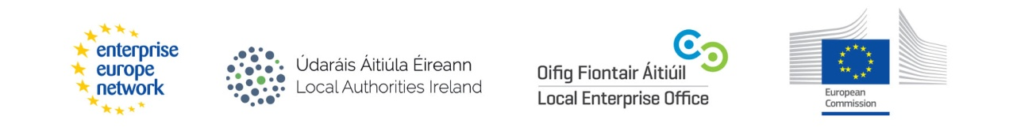

Venue
The EENGINEX Engineering Meet the Buyer and Matchmaking Event takes place at the new, state of the art CombiLift factory complex in Monaghan, where you will be given an opportunity to participate in a series of talks and factory tours, before engaging in pre-arranged meetings with a variety of senior engineering buyers from throughout Ireland and the EU.

Contact
Seamus McAdams
i2 Total Marketing
Tel: + 44 (0)28 7188 6131
Email: seamus@i2totalmarketing.com
Web: www.i2totalmarketing.com

