[](http://www.gmit.ie/) 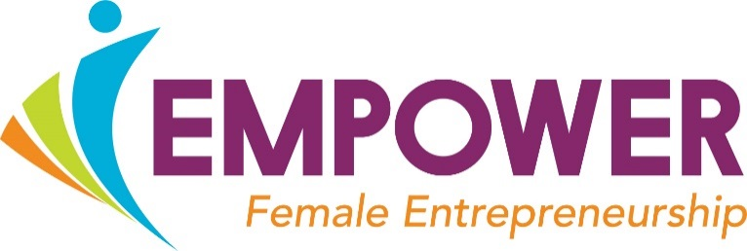 

**Application Form**

Female Entrepreneurship Programme

*Please forward applications to the* [*ihubmayo@gmit.ie*](mailto:ihubmayo@gmit.ie) *as soon as you can in order to be considered for the Programme.*

**Applicant’s name**_______________________________ **Phone number:** _________________

**Date of Birth:** ___________

**Email:** _____________________________________ **County:** __________________

**Linkedin Profile** _____________________ **Company website (if any)**: ________________________

**Please list any other members of the Team / Business and their role (s)**

_________________________________________________________________________

**Tell us what your (potential) business does in three sentences:**

*We Sell:* __________________________________________________________*(what is it?)*

*To:* ______________________________________________________________*(Customers?)*

*Who Need:* ________________________________________________________*(Problem?)*

**What is your ambition for the business?**

______________________________________________________________________________

**How much (if any) has been invested in the business to-date?** ________________________

**What are your barriers to scaling?** __________________________________________________________________________________________________________________________________________________________________

**What do you expect to gain from participation on the Empower Programme 2018-2019? Areas of help?**

__________________________________________________________________________________________________________________________________________________________________

**Can you commit (please highlight yes / no with tick or colour):**

**1 half Sat a month towards the Growth Programme?** Yes _____ No _____

**1 day per week (half day) for the Empower Start Programme?** Yes _____ No _____

**How did you hear about the Empower Programme?** ___________________________________

*‘This project is co-funded by the Irish Government and the European Social Fund as part of the Programme for Employability, Inclusion and Learning 2014-2020’*

 