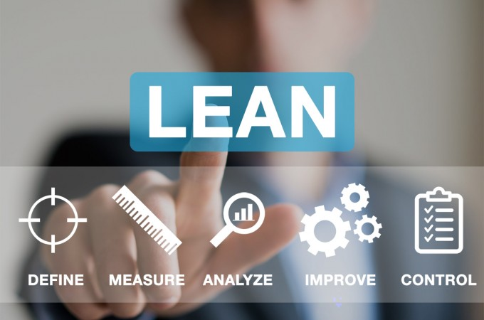

Lean for Micro Monaghan Application Form

Company name
Address
Date

Lean Business Offer
Directory of Service Providers

- Lean for Micro Monaghan

The Local Enterprise Office Carlow recognises the importance of the development of management skills for people managing their own micro or small enterprises. It also recognises the very substantial improvements in productivity and profitability that can result from the application of LEAN principles in an organisation and aims to support managers in effectively embracing LEAN methodologies in their businesses.

- How to submit your completed application

Applications will be accepted in electronic format only.

Please ensure completed application is returned to briege.quinn@leo.monaghancoco.ie

APPLICATION Part 1: Summary Profile

1.1 | Applicant and Business Contact Details
Name |  |  | Job Title
Company Name |  |  | Company address
Mobile No. |  |  | e-mail address
Tel. No.
 |  |  | Web Address
CRO Number |  |  | Year Business was established
How long has the business been trading?

1.2 | Company Sector (Of the following sectors listed-please mark with an X which sector your business operates in)
Business Services
Clothing & Fashion
Communications, Media & Entertainment Services
Customer Services
Craft
Electronics
Engineering
Environment/Green Technologies
Food Manufacturing & Processing
Food Primary Sectors
Furniture/Light Consumer Goods Manufacture
Manufacturing Other
Medical Devices Manufacture
Packaging Manufacturing
Software/IT
Business Services
Clothing & Fashion
Communications, Media & Entertainment Services
Customer Services
Other Please specific

1.3 | Brief Company Profile and History (e.g. background, ownership, specialist areas, key business sectors etc. Max 6 lines.)

1.4 | Business Profile  Please include current information on the following, with plans for future growth in Turnover and Staff Numbers.
 |  | Current | Projected 12 months | Projected 24 months
Turnover
Staff Numbers
Full-Time
Part-Time

1.5 | Business Profile  Please estimate the approximate percentage of your business turnover derived from:
SME companies in Ireland |  | Large companies in Ireland | International companies outside Ireland

1.6 | Business functions  Insert a 1 to which business function your business firstly requires support in. Continue this with a 2 for which business function your secondly requires support in.
Strategy |  | Finance | Marketing | Sales | Operations | Product / Service Development | Human Resources | Logistics | Environment / Sustainability | Management Information Systems

1.7 | Previous State Assistance (e.g Funding from the Local Enterprise Offices, Enterprise Ireland, New Frontiers participant)

1.8 | Previous Experience (If you have undertaken previous LEAN or Business Development project within the business in the past please outline max 10 lines)

1.9 | Ambitions for the programme (What are the main reasons that you will benefit from doing the Lean for Micro Programme, What goals have you for the programme?)

2.0 | Staff Profile (nominate up to 3 key staff members whom you would use on Lean Business assignments)
Staff name |  | Key specialist area or skill set
1
2
3

2.1 | Promoter Commitment (For participating businesses to benefit from the programme we require that the promoter/key decision maker in the business is committed to the programme)
Yes the promoter/key decision maker will be committed to the Lean for Micro programme |  | No the promoter/key decision maker will be unable to commit to the Lean for Micro programme

- Declaration

DECLARATION
I have read and understand the directory guidelines and declare that the information I have submitted above is true and accurate. I consent to the Local Enterprise Office Monaghan assessing the information provided for the purposes of gauging suitability for the Lean for Micro Monaghan Programme.

Signed:

Name:

Position in Company:

Date:

