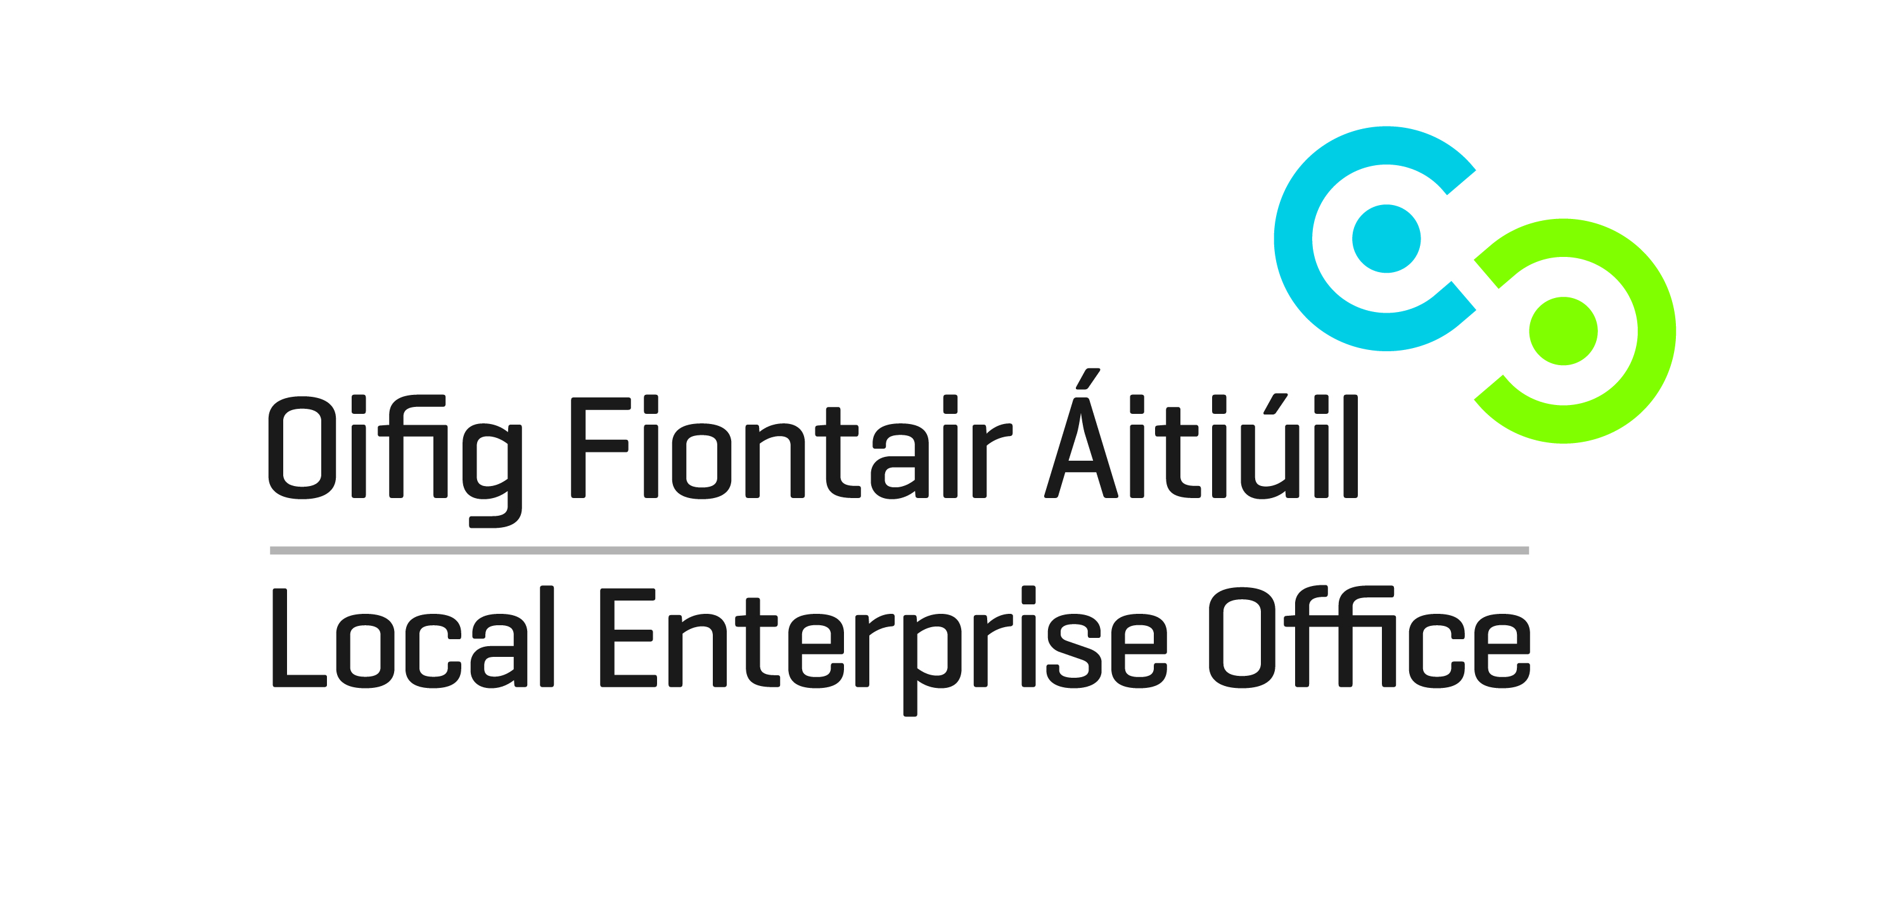
SHOWCASE 2016
Enterprise Zone
24th – 27th January 2016
RDS, Dublin

EXPRESSION OF INTEREST

Applicant Details
Business Name
Contact Name

Address
Telephone
E-Mail
Website

Tax Reference Number
Business Status  (please tick opposite) | Sole Trader  Limited Company  Partnership
Number of Employees
Brief Description of Business

Please outline the benefits to your business of participating in the show

Completed forms to be returned by post to
Local Enterprise Office Offaly, Aras an Chontae, Charleville Road, Tullamore, Co.Offaly
or by email to geraldine.beirne@leo.offalycoco.ie
Closing date for receipt of completed forms is Wednesday 8th October 2014.

