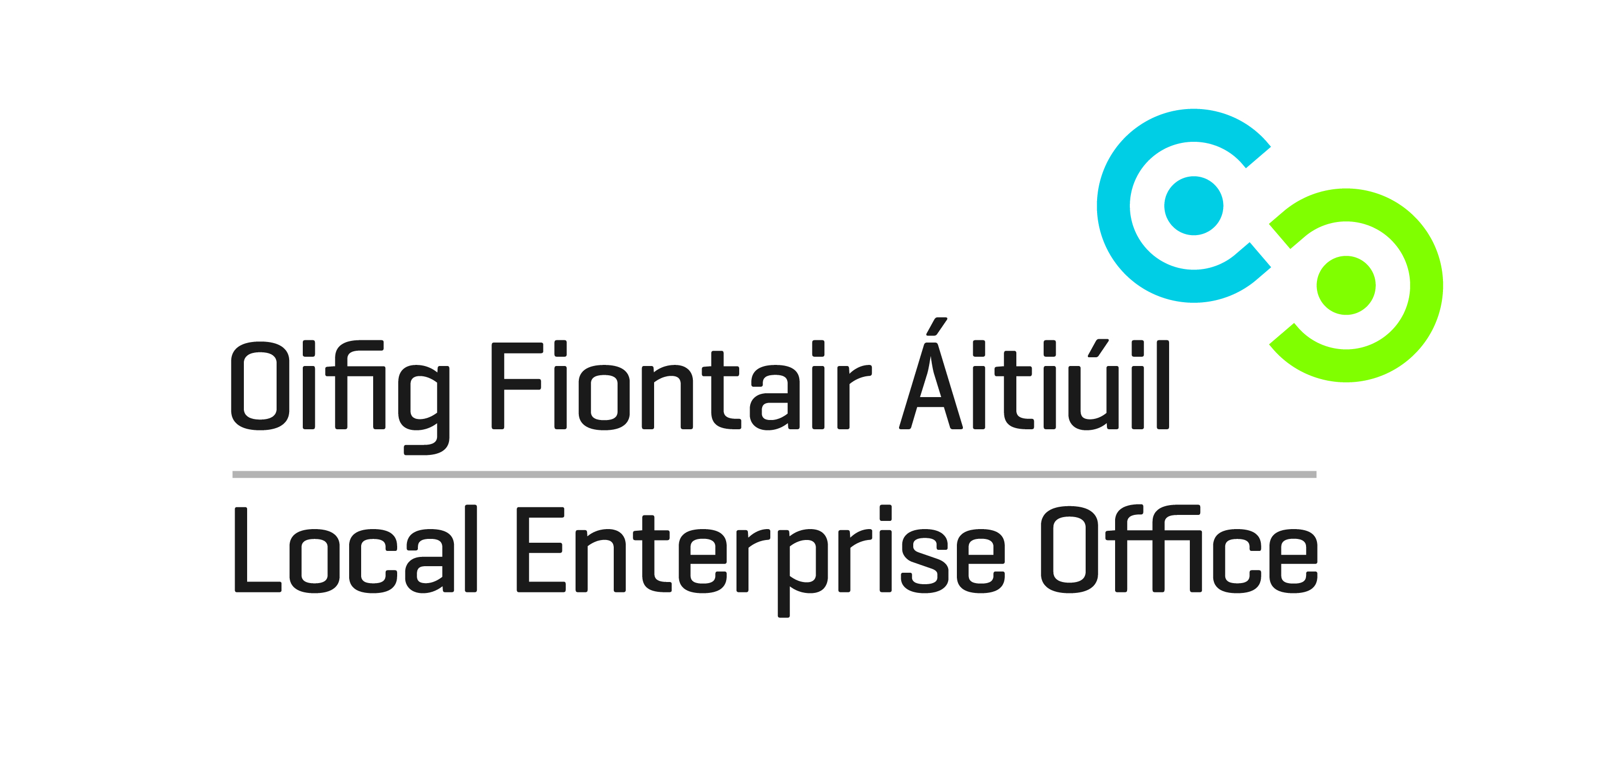
SHOWCASE 2019
Local Enterprise Showcase
January 2019
RDS, Dublin

EXPRESSION OF INTEREST/APPLICATION TO EXHIBIT

Applicant Details
Business Name
Contact Name

Address
Telephone
E-Mail
Website

Tax Reference Number
Business Status  (please tick opposite) | Sole Trader  Limited Company  Partnership
Number of Employees
Brief Description of Business

Please outline the benefits to your business of participating in the show

Completed forms to be returned by post to
Local Enterprise Office Offaly, Aras an Chontae, Charleville Road, Tullamore, Co. Offaly
or by email to geraldine.beirne@leo.offalycoco.ie

Closing date for receipt of completed forms is Wednesday 16th May 2018

NOTE:
Applications will be processed and a selection made on the basis of the quality of design in addition to the suitability of your operation and ability to supply the Wholesale Market.
The stand(s) to be allocated will be either 2m x 1m or 2m x 2m. Successful applicants will be required to pay the relevant subsidised cost (TBC but anticipated to be approximately €750) by 28th September 2018 or their space will be re-allocated to others on the waiting list.

