Membership Registration Form

Please complete and return to
Local Enterprise Office, Offaly County Council, Aras an Chontae, Charleville Road, Tullamore, Co. Offaly, Tel: 057 93 57480; Fax: 057 93 46868; email: info@leo.offalycoco.ie www.localenterprise.ie/offaly

Your Name
Business Name
Address
Telephone
Mobile
Email
Website
Facebook Page
Business Description

Your details are for in-house use only and will not be shared except with other ONE members attending the same meeting.

________________________________________________________________________

The Local Enterprise Office is committed to its transparency obligations under the General Data Protection Regulation (GDPR). Our data protection notice for personal data that is supplied to us by our clients is available at www.localenterprise.ie/legal This notice tells you about your privacy rights and sets out how we, as a Controller, collect, use, process and disclose your personal data relating to your interactions with us. We request that you read the notice carefully and that you ensure that it is made available to any data subjects (e.g. your employees) whose personal data you provide to us.

By ticking “I agree”, you confirm that: (a) you have complied with your own data protection obligations in respect of the personal data that you supply to us and that you are entitled to disclose such personal data to us; and (b) you will ensure that a copy of our data protection notice is sent to data subjects (e.g. your employees) whose personal data you provide to us.

[I agree] (Please Tick)

Signature of Applicant: ______________________ Date: ___________

Offaly County Council, Aras an Chontae, Charleville Road, Tullamore
Tel: 057 93 57480, Fax: 057 93 46868
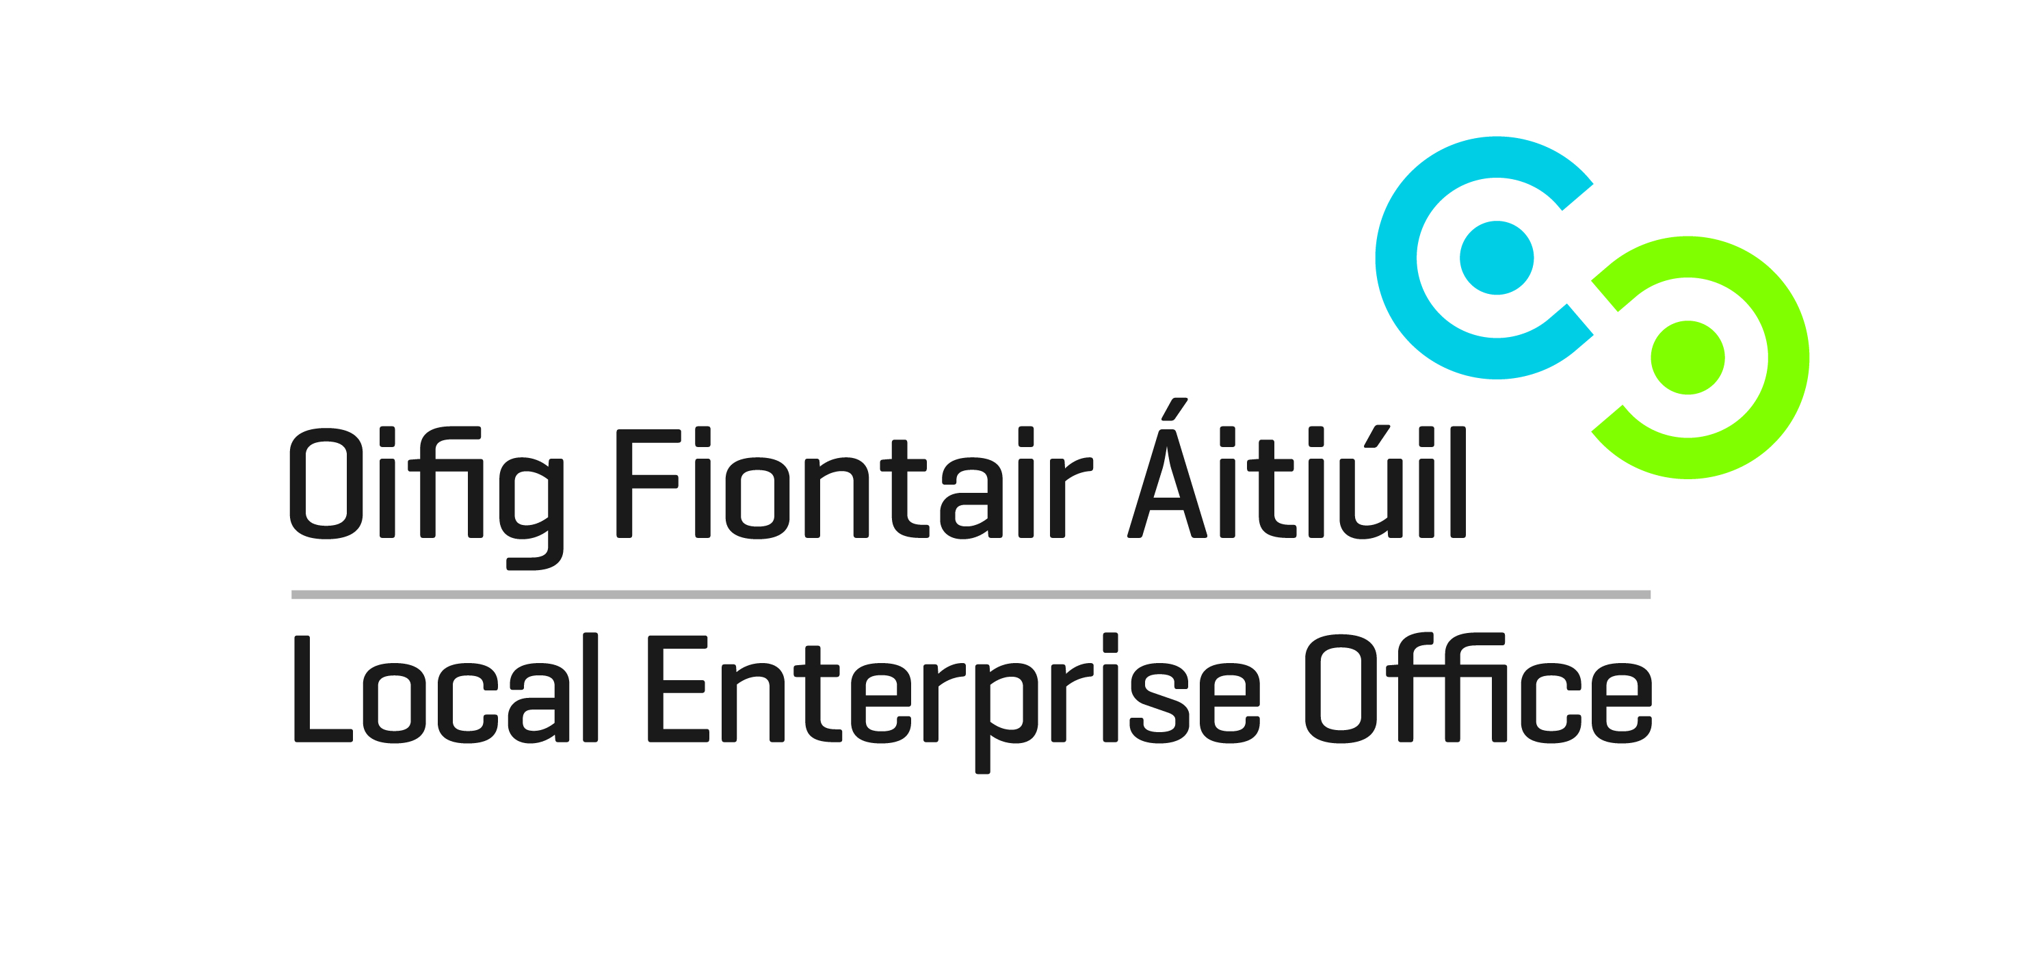
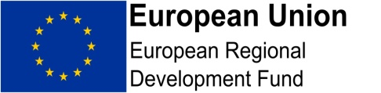
info@leo.offalycoco.ie; www.localenterprise.ie/offaly

