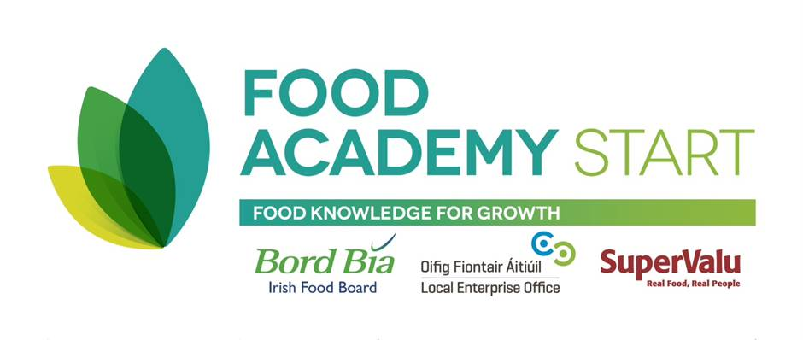

**THE FOOD ACADEMY START PROGRAMME – 2017**

**Local Enterprise Office Offaly**

**APPLICATION FORM -** In BLOCK CAPITALS please

Name:

Company name:

Address:

Phone number:

Mobile number:

E-mail:

Website (if applicable):

**CURRENT STATUS** (**please tick)**

Have you already started in business? No  Yes

Are you currently:

1. Employed

2. Self employed / a sole trader

3. In a Business Partnership

4. In a Limited Company

5. In a Co-operative

6. Unemployed/back to work scheme

7. Home duties

8. Other.

Have you ever been self-employed before? No  Yes

What is your most recent employment?

**YOUR FOOD BUSINESS**

Describe your business and list your products:

Describe your customer base/target market:

List any stores or foodservices where you may be already selling your product to:

How long has your business been in existence?

Have you sourced either a suitable food manufacturing premise or a suitable manufacturing option for volume production?

Have you access to funding for your food business? Please state YES or NO.

**EXPERIENCE AND PREVIOUS TRAINING** (PLEASE STATE IF YOU HAVE COMPLETED A START YOUR OWN BUSINESS PROGRAMME AND/OR A FOOD PROGRAMME PREVIOUSLY)

**YOUR GOALS** Explain in a few words what you want from this programme:

DATE ____________