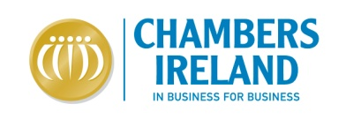
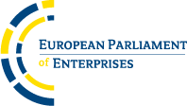

THE EUROPEAN PARLIAMENT OF ENTERPRISES
HEMICYCLE OF THE EUROPEAN PARLIAMENT, Brussels
THURSDAY 16 OCTOBER 2014

Chambers Ireland invites Local Enterprise Offices to nominate companies for the upcoming European Parliament of Enterprises (EPE) 2014.

This year’s EPE will play host to over 750 entrepreneurs from across the EU. Entrepreneurs will have a unique opportunity to debate with representatives of the European Union institutions and to provide them direct feedback on EU policies. The participants will be representing business of all sizes and sectors. There will be debates and voting sessions focusing on four key EU issues for businesses:
- Internationalisation
- Skills
- Finance
- Energy
Chambers Ireland encourages all Local Enterprise Offices to nominate companies interested in participating in this unique opportunity. Companies will have the chance to benefit from personal engagement with policy makers, numerous European companies, and international media. This is a great opportunity for our Irish businesses to make connections at a European level.

The event and the Irish participants will be profiled in InBusiness magazine and in other publications and media. This is an exciting opportunity to showcase the European dimension and international opportunities available to Chamber members.
There are only 10 places left, so nominate your companies soon.

*DEADLINE FOR CANDIDATE APPLICATION: September 17th, 2014.*

***Morning Breakfast to be held on the day of EPE, Thursday October 16th with Irish Members of the European Parliament (MEPs) to engage in a two-way discussion on key topics of interest at both Irish and European level.***

EPE Overview: http://www.parliament-of-enterprises.eu/index.php?cid=01&tid=home

For further information, or to nominate a potential participant company, please email: regina.saponari@chambers.ie

*Note - It is unlikely that there will be funding available, participant
companies will need the capacity to cover their own travel costs.

