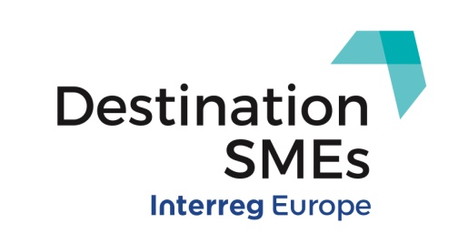
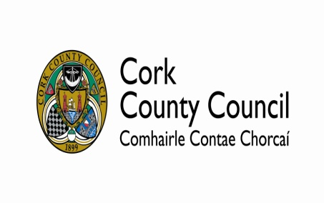
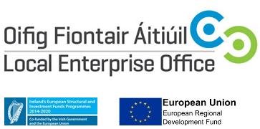

“Tourism Supports – Let’s Talk Business.”

Monday 2nd December 8:00am – 10:15am
Radisson Blu Hotel, Little Island.

Agenda
07:30 – 08:00 Registration
08:00 – 08:20 Breakfast and Networking
08:20 – 08:30 Welcome and Introductions (Sharon Corcoran, DOS Economic Development and John Lalor, EU Projects Office)
08:30 – 10:15 Tourism Supports Presentations
- The Role of Local Enterprise Offices and Supports Available (Sean O’Sullivan, Head of Enterprise, LEO South Cork)
- LEADER Capital Funding Supports (Valerie Murphy, Avondhu Blackwater Development Partnership)
- Ring of Cork and SECAD Tourism Skills Programme (Elga Ryan, SECAD)
- “Save Your Food” LEADER Food Funding Initiative (Tanya Fitzgerald, SECAD)
- Accelerate Programme Best Practice Success Story – Leahy’s Farm (Teresa Leahy,)
- Cork Harbour Islands Destination Brand (Gillen Joyce)
- Cork County Council Tourism supports (Rose Carroll, Tourism Department)
- Workshop Group Discussion/Survey
10:15 Close

