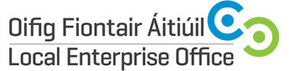

Local Enterprise Village
National Ploughing Championships / 20th-22nd September 2016
Expression of Interest

Contact Name:
Company Name and Legal Structure:
Address:
Landline Telephone:

Mobile Telephone :

E-mail Address & Website Address:

Year the company was established:
Company Description:

Product or Service Description:

Additional information that might be of interest to media? Eg awards/ exports?

Number of employees:
Social media accounts:
Any Special Requirements for NPA?

Would you like to use the product launch / seminar area during the NPA? (Additional cost of €100 applies for 1 hour usage) Yes/No
Preferred Briefing & Photography Session:
Cork – 14th June 2016
Tullamore – 16th June 2016
Dublin – 29th June 2016
LEO Contact Name | Trish O’Riordan
LEO Contact E-mail | trish.oriordan@leo.corkcoco.ie
IMPORTANT: Please include product photos or service marketing materials with your application

Signature : __________________________________________

