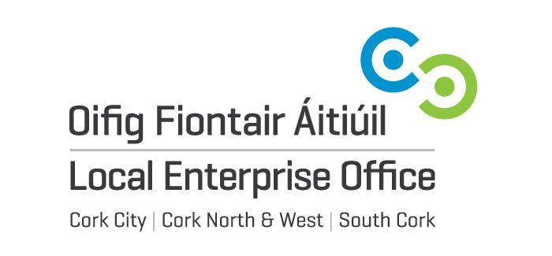
LOCAL ENTERPRISE OFFICES CORK - Application for Showcase 2019

Applicant’s Name
Position in the Business
Business Name
Business Address
Telephone Number
Email
Website
VAT Registration No. (if any)
No. of employees
Date business established

Status (tick your selected answer)
- Sole trader
- Limited company
- Partnership
- Other

Please give the turnover range for your business per annum:
(<€50,000, <€100,000, <€200,000, >€200,000)

Please tell us about your business and the products you offer

Please outline your main product range/discipline

Please outline the processes involved in the creation of your product

What are your objectives in exhibiting at Showcase 2019

Have your received support to exhibit at Showcase previously? If yes, please specify.

Specify the wholesale / cost price you charge retail buyers. You should provide prices for products that you plan to sell at Showcase 2019 (noting that retailers at a minimum may double the cost price and will have to include VAT at 23%)
 | Product Description | Wholesale Price / Prices given to Retail Buyers
Image 1 - attach
Image 2 - attach
Image 3 - attach

Please provide details of your packaging material, logos, point of sale and relevant marketing materials.

Where do you currently sell, your products to, please list and mention your best seller

Who are your competitors?

Social Media Activity – please list

The Local Enterprise Offices Cork are committed to its transparency obligations under the General Data Protection Regulation (GDPR). Our data protection notice for personal data that is supplied to us by our clients is available at www.localenterprise.ie/legal This notice tells you about your privacy rights and sets out how we, as a Controller, collect, use, process and disclose your personal data relating to your interactions with us. We request that you read the notice carefully and that you ensure that it is made available to any data subjects (e.g. your employees) whose personal data you provide to us.

By ticking “I agree”, you confirm that: (a) you have complied with your own data protection obligations in respect of the personal data that you supply to us and that you are entitled to disclose such personal data to us; and (b) you will ensure that a copy of our data protection notice is sent to data subjects (e.g. your employees) whose personal data you provide to us.

[I agree] (Please Tick)

Signature:
I hereby declare that the details given in this application, together with any supplementary information supplied are true and accurate

SIGNED DATE
Please email, post or deliver your completed application form by
Monday 11th of June 2018 at 4.00pm. Late applications will not be accepted.

Please note that it is recommended you submit a sample of your product range which you would like to bring to Showcase 2019. Any product samples should be delivered to your LEO no later than the closing date. You should collect your sample products from your LEO by Friday the 15th of June 2018.

SOUTH CORK Email: liz.murphy@leo.corkcoco.ie Tel: 021-4285200

