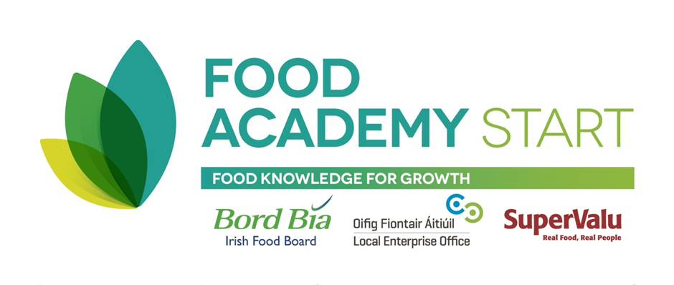

THE FOOD ACADEMY START PROGRAMME NO 2 - 2014

APPLICATION FORM - In BLOCK CAPITALS please
Please complete and return this form to Local Enterprise Office South Dublin ecoleman@leo.sdublincoco.ie
Name:

Company name:

Address:

Phone number:
Mobile number:
E-mail:
Website (if applicable):

CURRENT STATUS (please tick)
Have you already started in business? No Yes

Are you currently:
1. Employed
2. Self employed / a sole trader
3. In a Business Partnership
4. In a Limited Company
5. In a Co-operative
6. Unemployed/back to work scheme
7. Home duties
8. Other.

Have you ever been self-employed before? No Yes
What is your most recent employment?

YOUR FOOD BUSINESS
Describe your business and list your products:
Describe your customer base/target market:
List any stores or foodservices where you may be already selling your product to:

How long has your business been in existence?

Have you sourced either a suitable food manufacturing premise or a suitable manufacturing option for volume production?

Have you access to funding for your food business? Please state YES or NO.

EXPERIENCE AND PREVIOUS TRAINING (PLEASE STATE IF YOU HAVE COMPLETED A START YOUR OWN BUSINESS PROGRAMME AND/OR A FOOD PROGRAMME PREVIOUSLY)

YOUR GOALS Explain in a few words what you want from this programme:

DATE ____________

