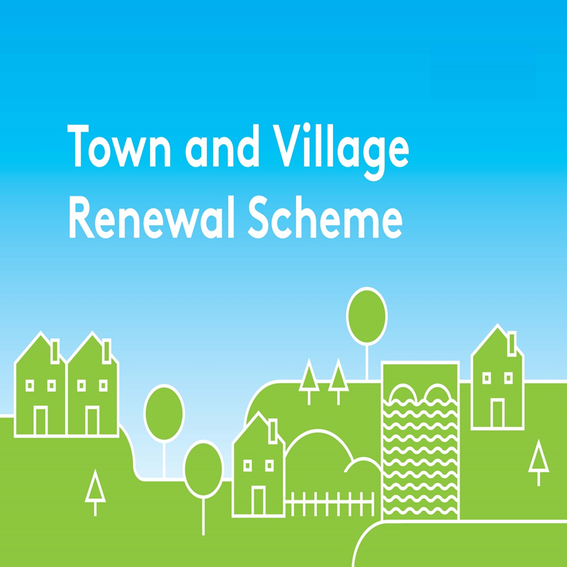

2019 Application Form

Please complete a separate application form in respect of each proposal.
All queries can be addressed to: townandvillage@drcd.gov.ie

Application Reference No

APPLICATION FORM

This form should be completed by Local Authority personnel and returned by e-mail to townandvillage@drcd.gov.ie by 28th June 2019. Please also submit a printed copy to the Department.

Name of Local Authority:

Town/Village covered:

Postal Address of project:

Amount of Grant Funding Requested:

Contact Name (Local Authority):

Contact email address:

Telephone Office:

Telephone Mobile:

- Synopsis of Project Proposal (Max. of 300 words). A detailed project proposal may be appended to this application. (Maximum 5 Pages, up to 10 pages for projects in excess of €100k):

- Explain the rationale for the choice of Town/Village, identify existing assets, amenities, accessibility, environmental aspect, retail mix, etc., and any deficits that need to be addressed or opportunities that can be built on.

- Detail other Department funding approved for this town/village previously if applicable e.g. REDZ, T&V, CLÁR, ORIS, RRDF etc.? Please list scheme, year and funding amount.

- If the proposed project is an element or phase of a larger project please explain why the full project is not being submitted to the Rural Regeneration and Development Fund.

- Please provide details of who will be implementing the project.

- Please detail how the proposed project will make a positive and visible impact on the town/village.

- How will the intended outcomes be measured? (Please supply any metrics or benchmarks that will be applied).

- If seeking funding of greater than €100,000, please provide details of how the project will deliver exceptional benefit to the town/village.

- When will work on the project commence and how long will the proposed work take to complete?
Proposed commencement date:

How long will the proposed work take to complete:

- FINANCIAL DETAILS
Local Authority VAT No.:
Tax Registration Number:
Tax Clearance Access Number:
CHY Number (if applicable):

- Detailed Costings for proposed Works
Please provide a detailed breakdown of all elements of the proposed works
(itemise various elements) | €
 | €
 | €
TOTAL COST | €
Grant Aid amount sought: (Max of 80% of Total cost) | €
The amount of Match Funding being provided: (at least 20% of Total Cost) Please provide breakdown on Application Overview Sheet. | €

Please ensure that the following 3 forms are returned to the Department by 28th June 2019:

(i) Application form
(ii) Application Overview sheet and
(iii) The Expression of Interest Overview sheets.

Please ensure that these forms are fully completed as an incomplete application may result in the project not being considered. Please return completed forms by e-mail to townandvillage@drcd.gov.ie by 28th June 2019 and also submit a printed copy to the following postal address: Town and Village Renewal Section, Department of Rural and Community Development, Government Buildings, Ballina, Co. Mayo, F26 E8N6.

DECLARATION

I request that assistance be given in support of the project as outlined and certify that, if made, the grant will be solely for the purpose for which it is approved. I confirm that the particulars of this application are correct and that the Local Authority
- confirms that match funding is in place and that evidence and source of the match funding is held;
- confirms that necessary permissions are in place or in train;
- confirms that evidence of ownership/lease (if applicable) is in line with Scheme Outline;
- confirms that a consultation process was undertaken with the Town/village and that the project was identified through the consultation process undertaken;
- confirms the relevance of project to the LECP/other plans;
- confirms that resources are available to provide for ongoing maintenance of project, if applicable;
- confirms that all tendering processes will comply with Public Procurement Guidelines;
- confirms that the project is not double funded.

Proof of the above is not required at the time of application but must be held on file by the Local Authority and must be available to the Department or its agents on request.

Signed: _________________________ _________________________Local Authority Director of Services
Date:_________________________

