National Enterprise Awards 2018
LOCAL ENTERPRISE OFFICE TIPPERARY
Entry Form
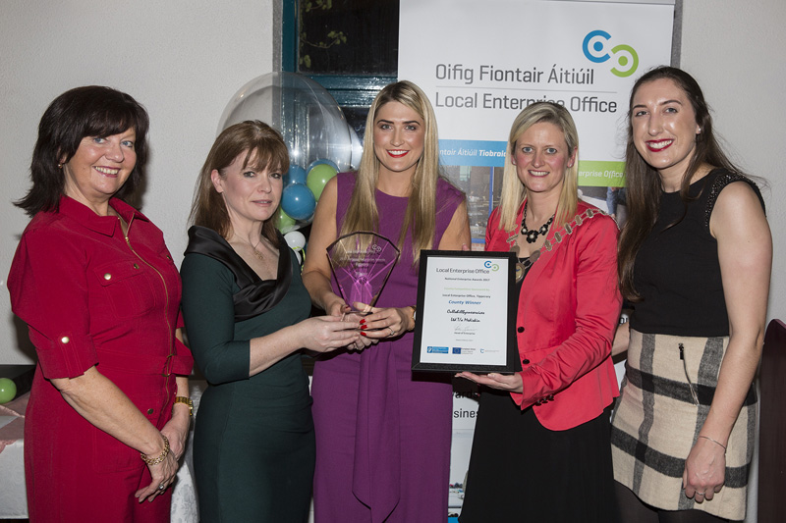

Applicant Name: _______________________

GENERAL INFORMATION

Name of Applicant: __________________________________________

Address: __________________________________________

__________________________________________

Region: Mid West/ South & East

Legal Status: (Tick one) Sole Trader Partnership Limited Company

Date of Commencement of Business: _________________________ ______

Phone: _______________________ Business ______________________ (Mob)

Website: _____________________ E-mail:____________________________

Business Information
What product or service do you supply?

Describe your own background and why you set up in business?

What do you see as the key strengths of your business?

In what way, and when, did your Local Enterprise Office help your business? (Please include the year, type and level of support i.e. Grant aid and/or Training Supports)

Has this business been grant aided by any other government agency such as Enterprise Ireland, An Bord Bia, Leader Partnership, Inter Trade etc . (If so give details i.e. Agency, Year, Grant Amount, Type etc)

Marketing Your Business
Describe what is different or innovative about your product or service?

Is your customer base local, regional, national, international? Please give details.

How do you market your business?

Are there potential new markets for your business and how do you plan to take advantage of these opportunities?

Social Media
What forms of social media do you use to promote your business and describe any campaigns you have undertaken?

Technology
How do you use technology in your business?

The Future of your Business
What long-term plans do you have for your business and how do you see it growing and developing over the next 3 years?

What do you see as the key threats/weaknesses to your business? How do you propose to address them?

Employment Details

 | 31/12/2015 | 31/12/2016 | 31/12/2017 | Projected 2018
Full Time
Part Time

Financial Details
Business Growth | 2015 | 2016 | 2017 | Projected 2018
Annual Sales
Net Profit

Investment | 2015 | 2016 | 2017 | Projected 2018
Own Funds
Loans
Grants
TOTAL

Please provide short description of your business for inclusion in media coverage and the NEA brochure – Max 50 words

(Please return your completed application form, together with a current Business Plan and financial statements to Local Enterprise Office Tipperary by 5.00p.m. on Wednesday 28 February . Applications will be accepted by email to rita.guinan@leo.tipperarycoco.ie or in hard copy which can be hand delivered or posted to Local Enterprise Office,, Civic Offices, Nenagh, Co Tipperary .

Signed: ___________________________________
Date: ___________________________________

