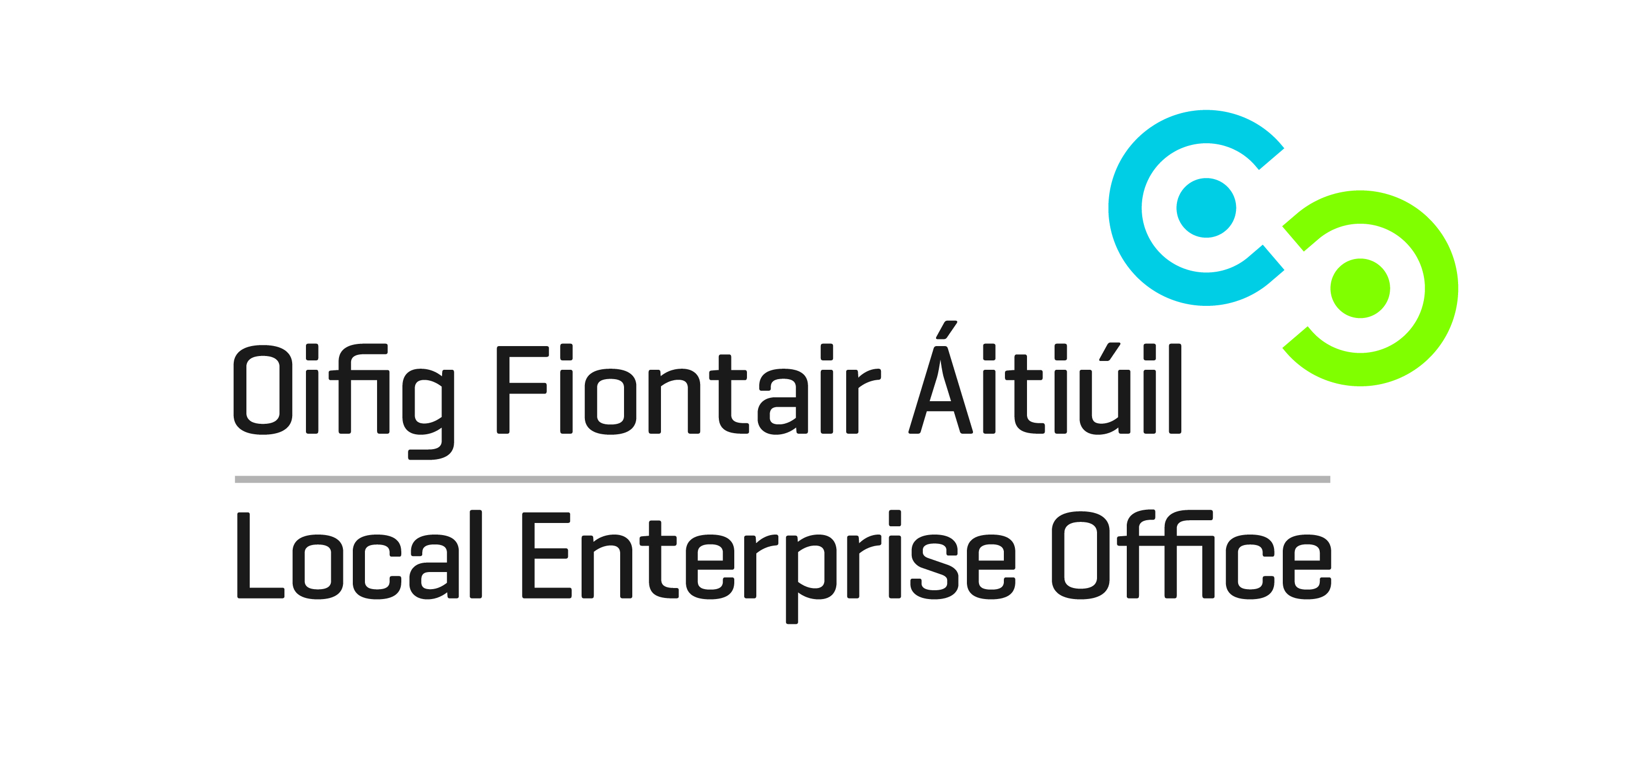

INVITATION TO QUOTE

FOR THE CO-ORDINATION OF THE

STUDENT ENTERPRISE PROGRAMME

2018/2019

Submission Guidelines

1. Introduction

Encouraging and promoting an enterprise culture is an important area of activity for the network of Local Enterprise Offices. The Local Enterprise Offices continually foster and promote entrepreneurship in the education system as a critical element in the future development of small business in Ireland. The Local Enterprise Office Tipperary is currently inviting submissions to quote for the delivery and co-ordination of the Student Enterprise Programme (hereafter referred to as SEP) in second level schools within County Tipperary for the 2017/2018 Programme. The SEP is a national enterprise education programme for secondary school students aimed at fostering an entrepreneurial spirit, through the practical experience of setting up and running a mini-business. Further information and details of the SEP can be accessed on www.studententerprise.ie

2. Student Enterprise

In seeking to develop a thriving enterprise culture, it is critical that young people from all backgrounds see enterprise as a viable career choice. Entrepreneurial qualities and mindset need to be fostered from an early stage. While recognising that participation in the Programme is on an entirely voluntary basis the following are key targets that the Local Enterprise Office Tipperary aims to achieve:

- Promote and create awareness of Student Enterprise Programme to all schools (29) in Tipperary
- A minimum of 22 schools participating in Student Enterprise Programme across any/all of the three categories
- At least 1,800 students exposed to Entrepreneurship as a result of the delivery of SEP in Tipperary.

3. Closing Date for receipt of proposal

The closing date for receipt of completed submissions is 4.00pm, Friday 31 August 2018. Proposals received after the closing deadline will not under any circumstances be considered.

Submissions should be sent in writing, as outlined under 7 below, marked ‘Proposal for Co-ordination of Student Enterprise Programme’ for the attention of Local Enterprise Office – Tipperary, Ballingarrane House, Cahir Road, Clonmel, Co. Tipperary or email to leo@tipperarycoco.ie with ‘Proposal for Co-ordination of Student Enterprise Programme’ in the subject line.

4. Costs and Proposal

Your price and proposal should be inclusive of all costs. The price should be a fixed sum and include the number of days and cost per day to deliver the SEP. It should also be inclusive of all travel and other expenses, overheads, insurances, etc to be incurred in the delivery of the contract. No additional costs will be incurred by the sub-contractor without the prior approval of Local Enterprise Office Tipperary. Please note that all necessary arrangements in connection with the promotion of the SEP, and the organising of associated workshops and of the County Final (including the cost of venue hire, etc.) will be arranged in agreement with and covered by Local Enterprise Office Tipperary.

5. General conditions of engagement

(i) This is a contract for the delivery of the SEP from September to the National SEP Final event usually held in April/May. Payments for all goods and services supplied will be made on the submission of appropriate invoices, in accordance with the Prompt Payment of Accounts Act 1997, as amended by the European Communities (late Payment in Commercial Transactions) Regulations 2002 (SI 388/2002). The payment schedule and invoicing arrangements will be agreed with the successful sub-contractor following their selection. The Local Enterprise Office Tipperary retains the right to withhold payment, where a sub-contractor has failed to meet his/her contractual obligations in relation to the delivery of goods/services to an acceptable level of quality.

(ii) The sub-contractor shall be required to fully comply with the tax clearance procedures for public service contracts and produce for inspection either a valid tax clearance certificate or other certification from the Revenue Commissioners as to their suitability on tax grounds for appointment;

(iii) The Local Enterprise Office Tipperary will provide full administrative back-up and support to the sub-contractor at all stages in and throughout the delivery of the SEP;

(iv) If in the opinion of Local Enterprise office Tipperary, the sub-contractor is not achieving the pre-set objectives or is deviating from the brief and terms of reference for delivery of the contract, their engagement will be terminated without the full cost being incurred.

6. Required Programme Activities

(i) The sub-contractor shall undertake to promote the SEP to 29 second level schools in the County and to secure minimum participation of 22 schools participating in same, having due regard to the targets set out under 2 above;

(ii) The sub-contractor will be expected, as a minimum, to undertake 5 (five) visits (max) to each second level school participating in the school during delivery of the contract, and to assist in all stages/aspects of the SEP from idea generation through to preparation of final submissions to the SEP Finals (at County & National level);
(iii) The sub-contractor will arrange regular liaison meetings with school representatives, Local Enterprise Office Tipperary staff and other stakeholders involved in SEP;
(iv) The sub-contractor will keep records of the number of students participating in each school and category, the gender ratio involved and final entrants in both county and national finals.
(v) The sub-contractor with the agreement of Local Enterprise Office Tipperary will arrange the provision of additional support/resources for students participating in SEP, including workshops and presentations on various elements of the SEP (e.g. sales & marketing; writing business plans; etc.) as and if required;
(vi) The sub-contractor will promote the SEP website www.studententerpriseProgramme.ie to schools, teachers and students and encourage the use of the website for registration and information requirements;
(viii) The sub-contractor will organise the County Final with the agreement of and in association with Local Enterprise Office Tipperary staff and the participating schools;
(ix) The sub-contractor will prepare promotional/publicity material and related PR for local media at various stages throughout the SEP programme; and
(x) The sub-contractor will liaise and communicate formally on behalf of the Local Enterprise Office Tipperary with the National Co-ordinator of the SEP.

(xi) The sub-contractor will co-ordinate Tipperary entries to the National Finals in terms of assisting students with final entry in terms of presentation of business plan and display stand, ensuring they are aware of deadlines and arrangements for the National Final event.

7. Submissions

Your submission should detail your proposal, approach, methodology and capacity to successfully address the Required Programme Activities. You should demonstrate that you possess the necessary technical and other expertise and experience to successfully undertake and complete the contract.
As per enclosed submission document, your proposal should clearly indicate the following:
- A clear overview of your approach/methodology to promote the SEP to gain maximum participation among second level schools;
- A clear overview of how you would deliver the SEP in participating schools;
- A clear outline of your specific experience, skills, profiles and qualifications;
- Details of your costs; number of days required and rate per day.
- Any further information that you wish to submit in support of your submission .
- Garda vetting may be required for each school in 2017/2018

Proposals/submissions should not normally exceed ten (10) pages.

8. Evaluation

The Local Enterprise Office Tipperary will not be bound to accept the lowest or any submission. Prospective bidders should note that the criteria to be applied in deciding on the successful award will involve scoring on the following:

- How the submission meets with all of the programme objectives (25%);
- Relevant experience of the bidder in delivering similar programmes, in particular working with young people in youth enterprise initiatives (30%).
- Value for money (20%); and
- Quality of approach (25%) in terms of administrative ability, communication skills and capacity to deliver the programmes.

The closing date for the receipt of submissions (including submissions by email) will be 4pm on Friday 31 August 2018. Submissions should be forwarded in a sealed envelope marked ‘Proposal for Co-ordination of Student Enterprise Programme’ to Local Enterprise Office Tipperary, Ballingarrane House, Cahir Road, Clonmel, Co. Tipperary or emailed to leo@tipperarycoco.ie with ‘Submission for Co-ordination of Student Enterprise Programme’ in the subject line. It will be the responsibility of the Company / Consultant to ensure that submissions are received by the Local Enterprise Office by the closing date. Submissions received after the closing deadline will not under any circumstances be considered.

