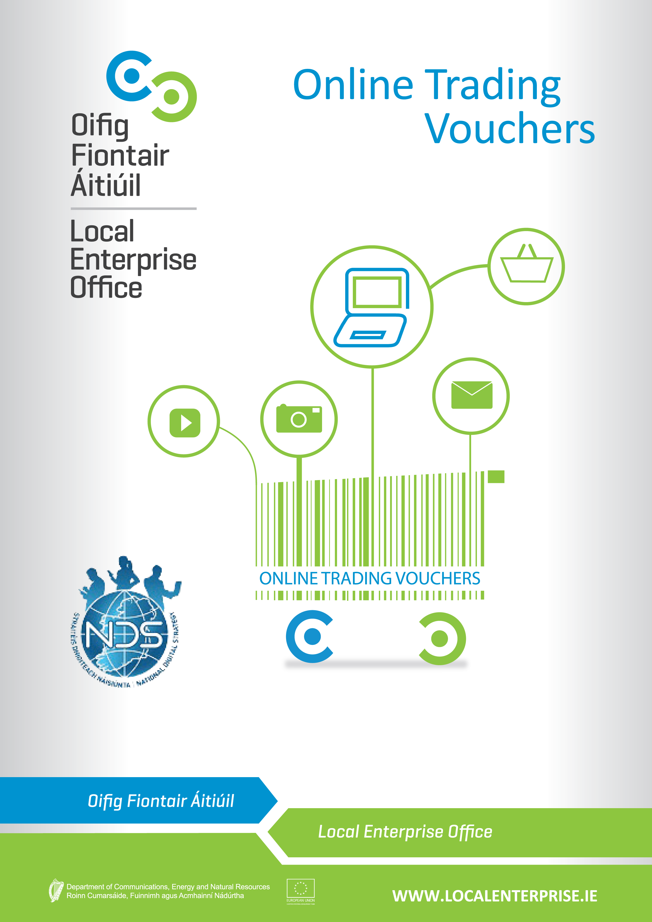
ONLINE TRADING VOUCHERS
With the trend ever increasing towards online spending it is estimated that only 23% of small Irish businesses are engaged in any meaningful way in eCommerce sales. For businesses employing less than ten people this percentage could be even lower. It is now believed that of online purchases made in Ireland that 70% of these are done in overseas markets.
There is now an urgency to ensure that businesses recognise that this is happening and that they are encouraged and supported to correctly respond to this digital reality.
In order to support this goal, the National Digital Strategy aims to get a further 2,000 businesses trading online by the end of 2015. To this end, the Department of Communications, Energy & Natural Resources (DCENR) has launched an Online Trading Voucher Programme and has teamed up with the Local Enterprise Offices to deliver this to Irish business. Following a successful first pilot phase in Dublin City, a wider pilot will now take place and businesses from the following Counties will be invited to apply:
CORK/DUBLIN/KERRY/LOUTH/SLIGO/WATERFORD
Information seminars will be available in each of the pilot areas over the next few weeks and it will be a condition of applying for the vouchers that applicants attend one of these seminars. At each seminar attendees will be informed of the purpose of the scheme and how best to use and get value from the application of the voucher.
Businesses are now invited to book a place on the seminars which can be done here (include link to online booking). The application process for the Vouchers will be a competitive process.
Eligibility Criteria
- Vouchers will be available to a maximum value of €2,500 or 50% of eligible expenditure (Net of VAT), whichever is the lesser;
- Voucher approval must be gained prior to incurring any expense;
- Own labour is not an eligible expense;
- Third party costs only will be considered;
- All third party/supplier invoices must contain proper business details (e.g. Tax and Business Registration details).
The vouchers are targeted at businesses with the following profile:
- Limited Online Trading presence;
- Less than 10 employees;
- Turnover less than €2m;
- Applicant business must be registered and trading for at least 12 months;
- Business must be located in one of the pilot areas under this phase of the scheme.
Ineligible Projects
- Companies with charitable status, commercial semi-state companies, “not for profit” organisations, trade associations and company representation bodies such as Chambersof Commerce are not eligible to participate in the innovation voucher initiative;
- Professional services specialising in IT type services who are already capable of trading online using existing in-house systems;
- Conferences and Seminars;
- Projects which are contrary to public policy;
- Duplication of support for projects which would be eligible for assistance from other State Agencies of EU funded Operational Programmes;
- Projects with employees in excess of 10 people;
- Projects deemed to be capable of proceeding in any event without scheme assistance i.e. deadweight;
- Projects essentially comprising importation and distribution.
What the vouchers can be used for
- IT consultation;
- Development or upgrade of an e-commerce website;
- Implementing Online payments or booking systems;
- Purchase of Internet related software;
- Purchase of online advertising (this purchase cannot make up any more than 30% of approved Voucher costs and can only be drawn down in one payment phase);
- Developing an app (or multiplatform webpages);
- Implementing a digital marketing strategy i.e. Social media marketing;
- Consultation with ICT experts for early stage adopters of online strategy;
- Training/skills development specifically to establish and manage an on-line trading activity.
What the vouchers cannot be used for
- Development of brochure websites;
- Purchase of non-internet related software;
- Anything other than online trading related activity.

EVALUATION PROCESS
- An evaluation committee will assess the applications and make recommendations for approval;
- A competitive process will be put in place to assist with selection process. Selection of successful applicant will be based on the following criteria:
  - Eligibility for scheme
  - Value added potential
  - Export potential
  - Job creation potential
  - Financial Sustainability
- Record decisions and report to the Local Enterprise Office approvals committee;
- In order to apply for a voucher applicants will be required to attend a training session on how to use and get the best value for money from the voucher.

VOUCHER ADMINISTRATION
- Letter of offer with Voucher to be sent out to successful applicant;
- Letter of offer signed, accepted and returned;
- Client has three months to complete the work as per their application;
- Client must attend pre-voucher application information seminar.
Voucher application and drawdown process:
Application
- Submit copy of completed and signed application form by hard copy;
- Soft copy of completed application to be supplied by email;
- Evaluation of applications and recommendations for approval;
- Application is approved by Local Enterprise Office Committee.

Drawdown
- Applicant and supplier sign declaration on the voucher and submit to Local Enterprise Office (LEO);
- Applicant and Supplier submit copy of an up to date tax clearance certificate ;
- Invoice from supplier containing CRO details and Tax registration number submitted to LEO for payment (Only suppliers with these basic criteria in place are eligible);
- Proof of payment to supplier submitted by applicant to LEO.

Post-Voucher reporting

By accepting a Trading On-line Voucher, businesses agree to provide information on the impact on their business of trading on-line;
- Reporting will include: Jobs (new or reallocated) , Exports and/or domestic market expansion, Increase Revenue, Reduced Costs, Expected follow on investment
Suppliers will be required to report on the impact of their products and services.
- Reporting will include how their product or service enabled: trading on-line, improved business performance, reduced cost, opened markets.
Acknowledgements
The trading on-line voucher scheme is an initiative of the National Digital Strategy, developed and funded by the Department of Communication, Energy and Natural Resources on behalf of Government. It is being administered by the Local Enterprise Offices on a pilot basis.

Sign by Business Name | Date

Declaration
I hereby declare that the information and details provided on behalf of the applicant business are accurate and true to the best of my knowledge and belief. I make this application as a duly authorised officer for and on behalf of applicant business for grant assistance on the basis of the information and details given. I have not sought and will not seek grant aid from any state agency or other sources in respect of this expenditure. I have read and fully accept the terms & conditions attaching to the ‘Online Trading Voucher’.
Further Terms
Applications for assistance for expenditure incurred prior to grant approval are ineligible. The Local Enterprise Office reserves the right to refuse any application and the right to terminate this grant scheme at any time without notice. The approval of applications and the payment of all monies are dependent on the availability of resources under this scheme from the Department of Communication, Energy and Natural resource. Applicants are advised to check availability of resources with Local Enterprise Office prior to applying. All applicants approved must draw down in full within three months of the date of offer. Failure to draw down all or any portion may result in automatic decommittal without notice, i.e. loss of voucher. The Local Enterprise Office may liaise/consult other agencies/local development programmes in relation to this proposal while respecting project confidentiality. Any false or misleading statement or the withholding of essential information from Local Enterprise Office (as determined by Local this scheme.
PLEASE NOTE: The Local Enterprise Office is not responsible for any disputes between the applicant and 3rd party suppliers. Therefore we recommend that you adhere to best business practice and get three quotes as well as carry out due diligence before selecting a supplier.
If your application is successful, an Online trading Voucher will be sent to you for you to forward to your preferred supplier.
- Payment will be made directly to the supplier upon receipt of the following:
- Copy of CRO registration
- Up to date tax Clearance Certificate
- Paid invoice from supplier
- Declaration of project completion by supplier(s) (signed online voucher)
- Bank statement showing proof of payment from the client company
- Payments will only be made with relation to approved expenses which form part of this application form
- All successful applicants agree to report on online trading upon completion of the scheme, again in 6 months and at annual intervals up to three years thereafter. Reporting will include: jobs (new or reallocated), increase turnover, exports and/or domestic market expansion, reduced costs, expected follow on investment. This may be conducted by approved independent evaluators.
- Applicants agree that on successful completion of their projects they will allow reference be made to them in case study materials which will be used to promote the voucher scheme more widely.
Online Trading Voucher Pilot Application: SIGNATURE FORM

This form will provide you with a project specification that you can use to circulate to suppliers and will also be the basis for nearly all your application for the voucher.
Name:
Company name:
Company address:
Telephone:
Mobile:
Email:
Website address: |  | Tick if not online

Business objective for your Trading Online project (Max 150 words):
What is it that your business expects this project to do that will help your business? Handle sales, generate new leads, handle customer service, etc… (please be as specific as possible)
Description of your Business's Products / Services (150 words max)
Overview of your businesses activities whether related to the project or not

Unique Value Proposition of your Products / Services targeted in this project (Max 150 words):
Look at your online competitors, decide what products/services you will focus on - not all of them need to be traded online. Why did you select what you have?
Your Target Market through this project (Max 150 words)
Who are your customers going to be?
Trading online competitors (list 3 to 5 with their a link to their websites):
When you use a search engine to look for the product /services your company offers, what companies/sites are displayed
Market expansion potential (Max 150 words):
Based on your target market and competitor analysis, how will this project help you grow your revenue? Export potential? Gain back lost market share to existing online traders?

Internal resources brought to the project
Internal resources brought to the project
Existing Assets the project should leverage off
What can you provide to suppliers more to work with? Social media presence you want to leverage? Design material? Photographs? Brand & marketing material?
Scope of work to be carried out (Max 150 words)
What are the specific deliverables of the project relating back to the business objectives?

The work you are seeking to have done by external service provider(s) will entail (click all that are applicable) | Yes | Unsure
IT Consultation
Project Management
New eCommerce site development (from scratch)
Upgrade of existing eCommerce site
Content Management System
Implementing an online payments system
App development
Digital Marketing Strategy and associated online advertising
Training specific to the establishment of trading online
Copy (written or graphic content) for website
Search Engine Optimisation (SEO) services
Analysis of existing site analytics

Business type:
CRO Number:
Year business was established
How long has the business been trading?
 |  | Current |  | Projected 12 months |  | Projected 24 months
Turnover
Staff numbers
- Full time
- Part-time
Trading Online Expenditure
 |  | Product / Service |  | Service provider |  | Cost (€ Excluding VAT)
Supplier 1
Supplier 2
Supplier 3
Add additional supplier quotes
Online Voucher request amount
- Expected cost based on quotes (ex VAT) |  | €
Eligible voucher amount requested €2,500.00 Maximum voucher award |  | €

Your Local Enterprise Office:
Application received!
You'll also receive a confirmation email that we've received your application.
VOUCHER PAYMENT CONDITIONS
* | If your application is successful, an Online trading Voucher will be sent to you for you to forward to your preferred supplier.
* | Payment will be made directly to the supplier upon receipt of the following:
1 | Copy of CRO registration
2 | Up to date tax Clearance Certificate
3 | Invoice
4 | Declaration of project completion by supplier(s) (signed online voucher)
5 | Bank statement showing proof of payment from the client company
* | Payments will only be made with relation to approved expenses which form part of this application form
* | All successful applicants agree to report on online trading upon completion of the scheme, again in 6 months and at annual intervals up to three years thereafter. Reporting will include: jobs (new or reallocated), increase turnover, exports and/or domestic market expansion, reduced costs, expected follow on investment. This may be conducted by approved independent evaluators.
* | Applicants agree that on successful completion of their projects they will allow reference be made to them in case study materials which will be used to promote the voucher scheme more widely.
* | INCLUDE RETURN EMAIL AND OFFICE ADDRESS FOR HARD COPY HERE
PLEASE NOTE: Local Enterprise Office is not responsible for any disputes between the applicant and 3rd party suppliers. Therefore we recommend that you adhere to best business practice and get three quotes as well as carry out due diligence before selecting a supplier.
IMPORTANT: Applications for assistance for expenditure incurred prior to grant approval are ineligible. The Local Enterprise Office reserves the right to refuse any application and the right to terminate this grant scheme at any time without notice. The approval of applications and the payment of all monies are dependent on the availability of resources under this scheme from the Department of Communication, Energy and Natural resource. Applicants are advised to check availability of resources with Local Enterprise Office prior to applying. All applicants approved must draw down in full within three months of the date of offer. Failure to draw down all or any portion may result in automatic decommittal without notice, i.e. loss of voucher. The Local Enterprise Office may liaise/consult other agencies/local development programmes in relation to this proposal while respecting project confidentiality. Any false or misleading statement or the withholding of essential information from Local Enterprise Office (as determined by Local Enterprise Office) will result in cancellation of any grant approved under this scheme
DECLARATION: I/We hereby declare that the above information and details are accurate and true to the best of my knowledge and belief and I make this application for grant assistance on the basis of the information and details given. I/We have not sought and will not seek grant aid from any state agency or other sources in respect of this expenditure. I have read and fully accept the terms and conditions attaching to the ‘Online Trading Voucher’ from Local Enterprise Office.

