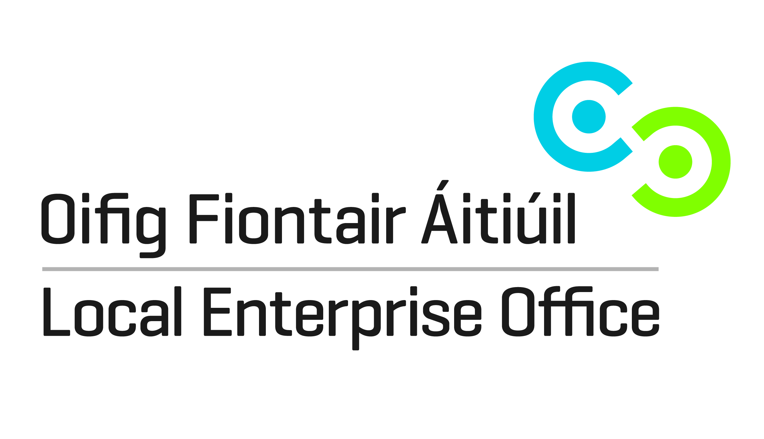
THE FOOD ACADEMY START PROGRAMME – 2016
Local Enterprise Office Waterford
APPLICATION FORM
Complete in BLOCK CAPITALS please
Name:
Company Name:
Address:

Tel Number:
Mobile Number:
Email Address:
Website:
(if applicable)
Preferred Programme Start date:
 |  |  | End Sept/ beginning Oct 2016
YOUR GOALS Explain in a few words what you want from this programme:

A Fee of €150 is required for participation on this programme
Fee Enclosed |  |  |  |  | Fee By Bank Transfer
Date:
Further Information
Current Status:
Have you already started in business? Yes / No

Circle the Tick the appropriate number below
Are you currently:
- Employed
- Self employed / a sole trader
- In a Business Partnership
- In a Limited Company
- In a Co-operative
- Unemployed/back to work scheme
- Home duties
- Other.
YOUR FOOD BUSINESS
Describe your business and list your products:

Describe your customer base/target market:

List any stores or foodservices where you may be already selling your product to:

How long has your business been in existence?

EXPERIENCE AND PREVIOUS TRAINING
(Please state if you have completed a Start your Own Business Programme, and / or a Food Programme previously.)

