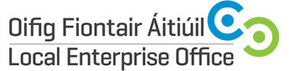

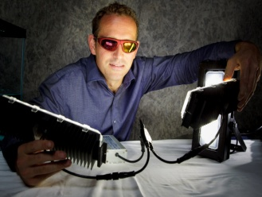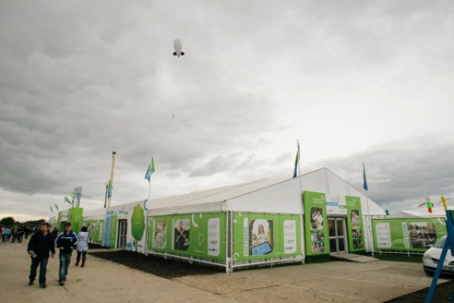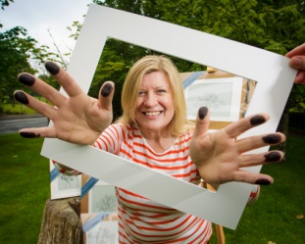

The Enterprise Village

National Ploughing Championships

Screggan, Tullamore, Co Offaly from Sept 19th – 21st 2017

Instructions to Local Enterprise Offices in respect of Booking for
Local Enterprise Village Stand Space

Issued : 12th April, 2017

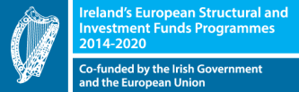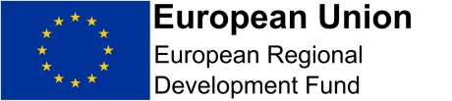

Instructions to Local Enterprise Offices in respect of Booking for

Local Enterprise Village Stand Space

Each Local Enterprise Office is allocated 1 stand:

- Each Stand is 3 x 2 Meters and the client cost is €500
- There is no VAT applicable to the above rates
- Monies will be collected by Carlow LEO upon confirmation of the client’s successful application.
- There is only 1 stand available per LEO, in the case of a LEO not using their stand they should declare same and expressions of interest for additional stands will be sought from the Network and the LEOs picked at random.
- No Non-Shell Scheme or group stand options are available.
Each Stand Holder gets:

- Space as per allocation
- Name Plate
- Double Socket
- Spot Lights X 2
- 2 X Exhibitor Passes
- 1 X Exhibitor Car Park Pass (Parking is free at the NPA)
- 1 X Build & Break Pass
The exhibition area has WIFI, Toilets, Storage Areas etc. Storage Areas are allocated on a first come, first served basis.

Selection of Clients

The aim of the Enterprise Village is to showcase the best clients countrywide. It is up to each LEO to select the client they put forward on the stand but the client should be at least 12 months trading and should represent the best of your projects as the aim of the Enterprise Village is to showcase the best the LEOs have to offer nationwide. Also each LEO should ensure that the chosen client will get the most from a consumer exhibition which attracts over 200,000 visitors.

The process and key milestones for clients are as follows:

- Submissions of expressions of interest from each LEO by 5th May, 2017.
- Central Selection by LEO Committee will then take place.
- Notification to clients by end May 2017 and Invoices distributed by Carlow LEO for payment directly to Carlow County Council.
- Payment by end of June 2017
- Briefings for Clients on a Regional basis June & July
- Launch July/August
Selection of Clients by Central Committee

In order to avoid a large variety of similar products a central selection process will be engaged by the LEO committee. LEOs should submit 2 projects with one listed as the preferred, and another as the substitute to be considered in the event that the committee are concerned about too many of the same products being part of the Enterprise Village. The committee will review and give feedback on overall product mix. Only 1 project will be selected per LEO and this process will be completed by Mid-May 2017.

Food Clients
There is no doubt that some LEOs will nominate Food Clients. Due to the NPA regulations Food Clients are only allowed to have food sampling and/or sale for home use in accordance with our permit (i.e. sale of product for consumption on site is strictly prohibited under terms of our display permit). For Food companies who use equipment there is usually additional costs and this will be advised at the briefing.

We have in place the general requirements for Food Clients i.e. Sinks, Toilets etc.

Application Process:

- Applications should in the first instance be returned to the clients local LEO. (We enclose a letter/email and application form etc. which you can use).
- Once you have selected your 2 companies, application Forms should be returned to the LEO Carlow Office, no later than 5th May, 2017.
- The Committee will meet to carry out the selection process Mid-May.
- Following selection, the client will get an invoice by end of May 2017 for payment by June 26th 2017. In the event of payment not being received from the client the position may be re-allocated to another party. It is expected that demand will exceed supply. If any LEO does not wish to canvass or submit clients for their LEO territory please advise LEO Carlow Office as soon as possible.
- The client must attend a client briefing the purpose of which is to
  - Brief clients on the NPA
  - Do Photography for PR / Signage & Marketing
  - Introduce NPA Clients to our contractors for additional requirements
This has worked really well in the past for us and the clients can use the quality images afterwards.

The briefings will take place as follows:

Dublin – Crown Plaza, Santry 28th June, 2017
Tullamore – Tullamore Court Hotel 5th July, 2017

- In August 2017 a final site plan will be distributed to all parties.
Media & PR
A media and PR Plan is being put in place for the event and the NPA has been engaged to co-launch the event to use their media channels to promote the work of the Local Enterprise Offices.

Selection of Clients:

The LEO village provides clients with a first opportunity to showcase at the NPA and preference should be given to new clients each year who have innovative new products to display so as to keep the village fresh and new. In keeping with this goal no client should be included on more than 2 occasions.

Client(s) chosen should represent the type of clients LEOs prioritise for support (e.g. M1, award winners, IBYE etc.) The committee believe it is important to stress to clients that this is first and foremost an opportunity to showcase their products and build contacts with a view to future sales as opposed to being an event to be measured by sales made over the 3 days.

In general the following will not be considered:

- Professional Services i.e. Tax Advisors , Accountants etc.
- Personal Services i.e Beauty Services , Coaching etc.
Location of the Village:
We are at present engaged with the NPA in respect of the Marquee and have requested that the Village be placed in a central location within the site. This is based on feedback from last year.

Co-ordinator:
Following a tender process a co-ordinator will be appointed shortly. The contract will commence at the start of May. Any queries in relation to ploughing should be directed to the co-ordinator whose details will follow.

SAMPLE LETTER/E-MAIL TO CLIENTS
Opportunity to exhibit at the ‘Local Enterprise Village’ at NPA 2017

Dear XXX

As you may know the National Ploughing Championships are being held in Screggan, Tullamore, Co. Offaly from 19th – 21st September, 2017 where over 250,000 consumers will visit a 50 acre exhibition and trade arena. This is a wonderful opportunity to showcase the quality and high standards of goods and services supported by the Local Enterprise Office.

As part of its National Programme the Local Enterprise Offices are hosting a Local Enterprise Village to provide an opportunity for clients to take full advantage of this unique consumer event. Each Local Enterprise Office has 1 stand available for its clients.

XXX LEO is now inviting any clients interested in availing of this stand to complete the attached ‘expression of interest’ form and return to our office by 1st May 2017. Please note that priority will be given to enterprises manufacturing their own product or offering an innovative service relevant to the audience expected at the show. Once your expression of interest form has been received it will be considered centrally and successful applicants will be advised by email Mid-May, 2017.

Chosen exhibitors will be expected to attend a client briefing and photography session at one of the following locations:

Dublin – Crown Plaza, Santry 28th June, 2017
Tullamore – Tullamore Court Hotel 5th July, 2017
Exhibitors will be advised at confirmation of booking stage. The session will commence at 10.30am. Attendance at one of these sessions is compulsory as part of your booking. These sessions provide you with the opportunity to 1) obtain guidance on the NPA Exhibition, 2) obtain high quality photography which is used for signage, publicity and PR and 3) meeting with the exhibition contractor to discuss further requirements.

Please note that set up will be scheduled for 17th and 18th September and all companies must be available for setup at given time.

As part of this ‘Local Enterprise Village’ each company will receive:
- Exhibition Space 3 x 2 meters
- 2 x Exhibitors Passes
- 1 x space in exhibitor car parking area (general parking is free at the event)
- Electricity Supply
- Access to PR Opportunities
- Exhibition Advice
The cost of stands is highly subsidised and costs €500 for a 3 x 2 meter stand. Please note that this is first and foremost an opportunity to showcase your products and build contacts with a view to future sales as opposed to being an event to be measured by sales made over the 3 days. Food companies can serve samples only or sell products for home use.

Yours etc.

National Ploughing Championships / 19th and 21st September 2017
Expression of Interest
Contact Name:
Company Name and Legal Structure:
Address:
Landline Telephone:

Mobile Telephone :

E-mail Address & Website Address:

Year the company was established:
Company Description:

Product or Service Description:

Additional information that might be of interest to media? Eg awards/ exports?

Number of employees:
Social media accounts:
Any Special Requirements for NPA?

Preferred Briefing & Photography Session:

Session 1: Dublin 28th June, 2017
Session 2: Tullamore 5th July, 2017
LEO Contact Name
LEO Contact E-mail

Signature : __________________________________________

IMPORTANT: Please include product photos or service marketing materials with your application

