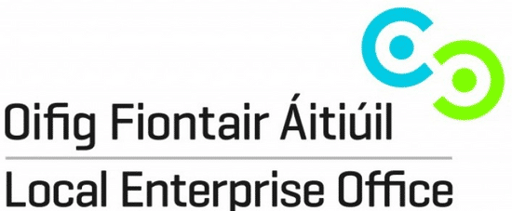

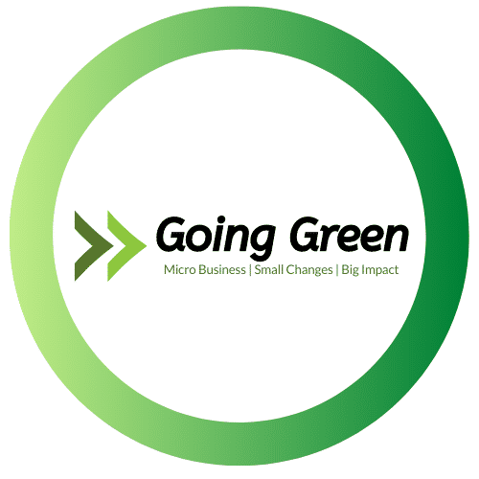

Application Form
Deadline for Applications: Friday 24th July at 5pm

Application Form
COMPANY INFORMATION
Company Name
Address
Number of Employees
Estimate Annual Turnover
Sector
Date Trading Commenced
Description of Business

YOUR NOMINATED CONTACT PERSON
Nominated Person
Job Title
Address
Phone Number
Email

COMPANY RESOURCE SPEND |  |  | (Information can be obtained from bills and company records)
 | Annual Cost (€) | Annual Quantity (tonnes, litres, kWh). Optional.
Electricity
Oil
Gas
Water
General Waste
Petrol/Diesel

HOW YOUR BUSINESS PLANS ON GOING GREEN
Environmental area of most interest for your business  (please underline) | Emissions | Water | Waste | Biodiversity
Outline your objectives for your business as part of the Going Green Programme?
What are your anticipated outcomes for your business resulting from the Going Green Programme?
Indicate environmental actions your business would be interested in? E.g. energy efficiency, better waste management, better water management, biodiversity projects, etc.

Terms and Conditions
Qualifying Criteria for Participant Enterprises
Enterprises must:
- Employing 10 or less staff
- Have a turnover of less than €2 million per annum
- Be located within the geographical area covered by the Going Green Programme i.e. within counties of Laois, Longford, Offaly or Westmeath
- Cooperate with the Local Enterprise Office of the county in which they are located
- Operate within the commercial business environment and therefore must NOT hold charitable status, be commercial semi-state company, trade association, or a company representative body
- Not-for-profit and social entrepreneurship applicants are ineligible unless they operate in a commercial domain
- Demonstrate an environmental-benefit for any changes made under the programme
- NOT have received any funding for this proposal from any other source
- Have a valid Tax Clearance Certificate (T.C.C.). This is required by a business that has been approved state funding or confirmation from the applicant by the provision of tax number, tax district and a statement that the applicant is up to date in his/her tax affairs. All participant businesses will be required to provide a valid certificate/ confirmation to the Local Enterprise Office before any grant payments can be made.
- A point of contact must be nominated from your business for all communication related to the Going Green Programme. This person must be familiar with all aspects of the business considered pertinent to the Going Green Programme including, but not limited to, company resource data and company expenses related to this data. This person must have the authority to share such information with the LEO, the Programme Coordinator and the Environmental Auditor. This person must be available to attend one of the two compulsory training workshops and must also be available for the site visit from the Environmental Auditor and be available to liaise when necessary with the Programme Coordinator, the Environmental Auditor and the local LEO in relation to the Going Green Programme.

Grant Funding Terms and Conditions:
- Grant funding must be for projects which will result in a positive environmental impact. This is an essential criterion, with the Local Enterprise Offices, in consultation with the Environmental Auditor, determining all projects validity with regard to positive environmental impact
- Grant covers 80% of eligible costs (net of VAT) to a max of €5000
- Applications must be made prior to any expenditure being incurred
- Only expenditure items agreed to with the Local Enterprise Offices and that that are incurred after the date of application may be considered
- A quotation must be provided in respect of each item of planned expenditure
- Written approval from the Local Enterprise Office must be gained prior to incurring any expense.
- Payments will be made to approved projects on receipt of proof of payment of all qualifying and approved expenses
- Third party costs only will be considered
- All third party/supplier invoices must contain proper business details (e.g. tax or business registration details or proof that the supplier is a registered business in the territory in which the supplier is located)
- Payments to State Bodies (including Local Authorities) as well as General Subsistence/Out-of-Pocket Expenses are excluded

- Own labour is not an eligible expense
- Local Enterprise Office requires all applicants to be in a position to drawdown any funding offer within a maximum of 6 months of any letter of offer. In the event of a funding offer being made, any approved amount not drawn down by the offer expiry date will automatically be decommitted.
- The Local Enterprise Office is not responsible for any disputes between the applicant and 3rd party suppliers. Therefore, we recommend that you adhere to best business practice and get three quotes as well as carry out due diligence before selecting a supplier. Disclaimer – For the avoidance of doubt it is understood and accepted that it is the applicant companies who are selecting and entering into a contract with third parties. The State and its agents (including Local Enterprise Office(s), Enterprise Ireland or any Government Department) does not accept any liability whatsoever in respect of any deficit in or consequences arising from products or services procured by or provided to companies under this scheme. In submitting your application under this scheme, you are confirming that you understand and accept this disclaimer.

Application and Drawdown Terms and Conditions
- Read the terms & conditions
- If satisfied your business is eligible, submit copy of completed and signed application form in hard copy to your local LEO (Laois, Longford, Offaly or Westmeath) and a soft copy of completed application to be supplied by email to the same LEO.
- Evaluation of applications will be conducted by an evaluation committee who will assess the applications and make recommendations for approval. A competitive process will be put in place to assist with selection process. Selection of successful applicant will be based on the following criteria:
  - Eligibility for scheme
  - Potential for improvements based on Company Resource Spend
  - Business objectives and outcomes alignment to the Going Green Programme
- All decisions regarding the selection of successful applicants will be recorded and reported to the Local Enterprise Office for the final decision
- If your business’s application is successful, a letter of offer will be sent to your business
- Letter of offer must be signed to be considered accepted and returned to the local LEO
- Successful business’s nominated point of contact must be available to liaise with LEO, the Environmental Auditor, the Programme Coordinator and must be available for the site visits with the Environmental Auditor and must attend one of the two training workshops sessions on behalf of the micro-business, which are to be arranged at a later date.
- Drawdown:
  - Payment will be made directly to the successful applicant upon satisfactory submission of the following from the applicant:
    - Original invoice from the supplier along with bank statement showing payment for same
    - Declaration of completed works by Programme Coordinator
  - All work must be completed and paid for prior to claim
  - Payments will only be made with relation to approved expenses which form part of this application form.

  - All successful applicants agree that they will allow reference to be made to them in case study materials, which may be used to promote the Going Green Programme more widely.
- Interval and post Going Green reporting:
  - By participating in the Going Green Programme, successful applicants agree to report on their environmental projects resulting from their participation in the scheme at annual intervals up to three years thereafter. Reporting will include: reduced annual cost and annual quantities of electricity, oil, gas, water, waste, diesel and/or petrol.

Data Use Terms and Conditions
Freedom of Information:
- The Local Enterprise Offices will not release any information received as part of this application unless it is required by law, including the Freedom of Information Act 2014. The Local Enterprise Offices will, in all cases where a request under the Freedom of Information Acts is made, consult with applicants before deciding on disclosure of such information.
Data Protection:
- The Local Enterprise Office is committed to protecting and respecting your privacy. Our Data Protection Notice tells you about your privacy rights and sets out how we, as a Controller, collect, use, process and disclose your personal data relating to your interactions with us. Please refer to
www.localenterprise.ie/legal for copies of our privacy notices. This notice contains important information about how we process personal data that is supplied to us by clients. We request that you read the notice carefully and that you ensure that it is made available to any data subjects (e.g. your employees) whose personal data you provide to us.

Further Terms:
- Applications for assistance for expenditure incurred prior to grant approval are ineligible. The Local Enterprise Office reserves the right to refuse any application and the right to terminate this grant scheme at any time without notice. The approval of applications and the payment of all monies are dependent on the availability of resources. Applicants are advised to check availability of resources with Local Enterprise Office prior to applying. All applicants approved must draw down in full within six months of the date of offer. The Local Enterprise Office may liaise/consult other agencies/local development programmes in relation to this proposal while respecting project confidentiality. Any false or misleading statement or the withholding of essential information from Local Enterprise Office (as determined by Local Enterprise Office) will result in cancellation of any grant approved under this scheme.
Deadline for Applications: Friday 24th July at 5pm
Return Completed Going Green Application Forms to:
Catherine.darby@leo.westmeathcoco.ie
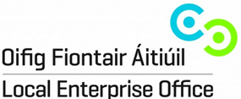
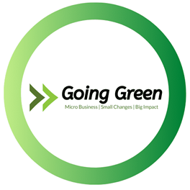
Local Enterprise Office, Westmeath
Áras an Contae,
Mullingar
Co. Westmeath
044 9338945 | Catherine.darby@leo.westmeathcoco.ie

