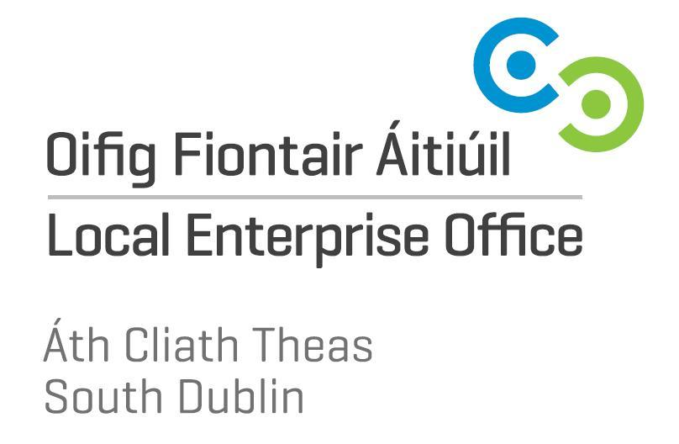

County Hall, Tallaght, Dublin 24: Tel 4149000; email: info@leo.sdublincoco.ie; www.leo.sdublincoco.ie

Student Enterprise Programme

Materials Allowance Draw Down Form 2019/2020

- Name of School:

2. School Principal:

3. School Address:

4. School Telephone no.: School Email:

5. Name Business Teacher:

6. Years participating: 1st yr 3rd yr 5th yr

2nd yr 4th yr 6th yr

7. (a) Number of students participating:

(b) Number Males:
(c) Number Females:

8. Date programme commenced:

9. Materials Allowance Claimed:

10(a) Teachers signature:

Note All completed draw down forms to be returned with completed
SEP School Entry Form to Local Enterprise Office
South Dublin by 18th October 2019. Please do not submit this
form unless you intend to fully participate in the SEP Awards.
As payments will be made by electronic transfer directly to the
school bank account, please complete the attached Supplier Set
Up form and return it with your draw down unless you have
previously done so.

For Office use only:
Authorised for payment:

