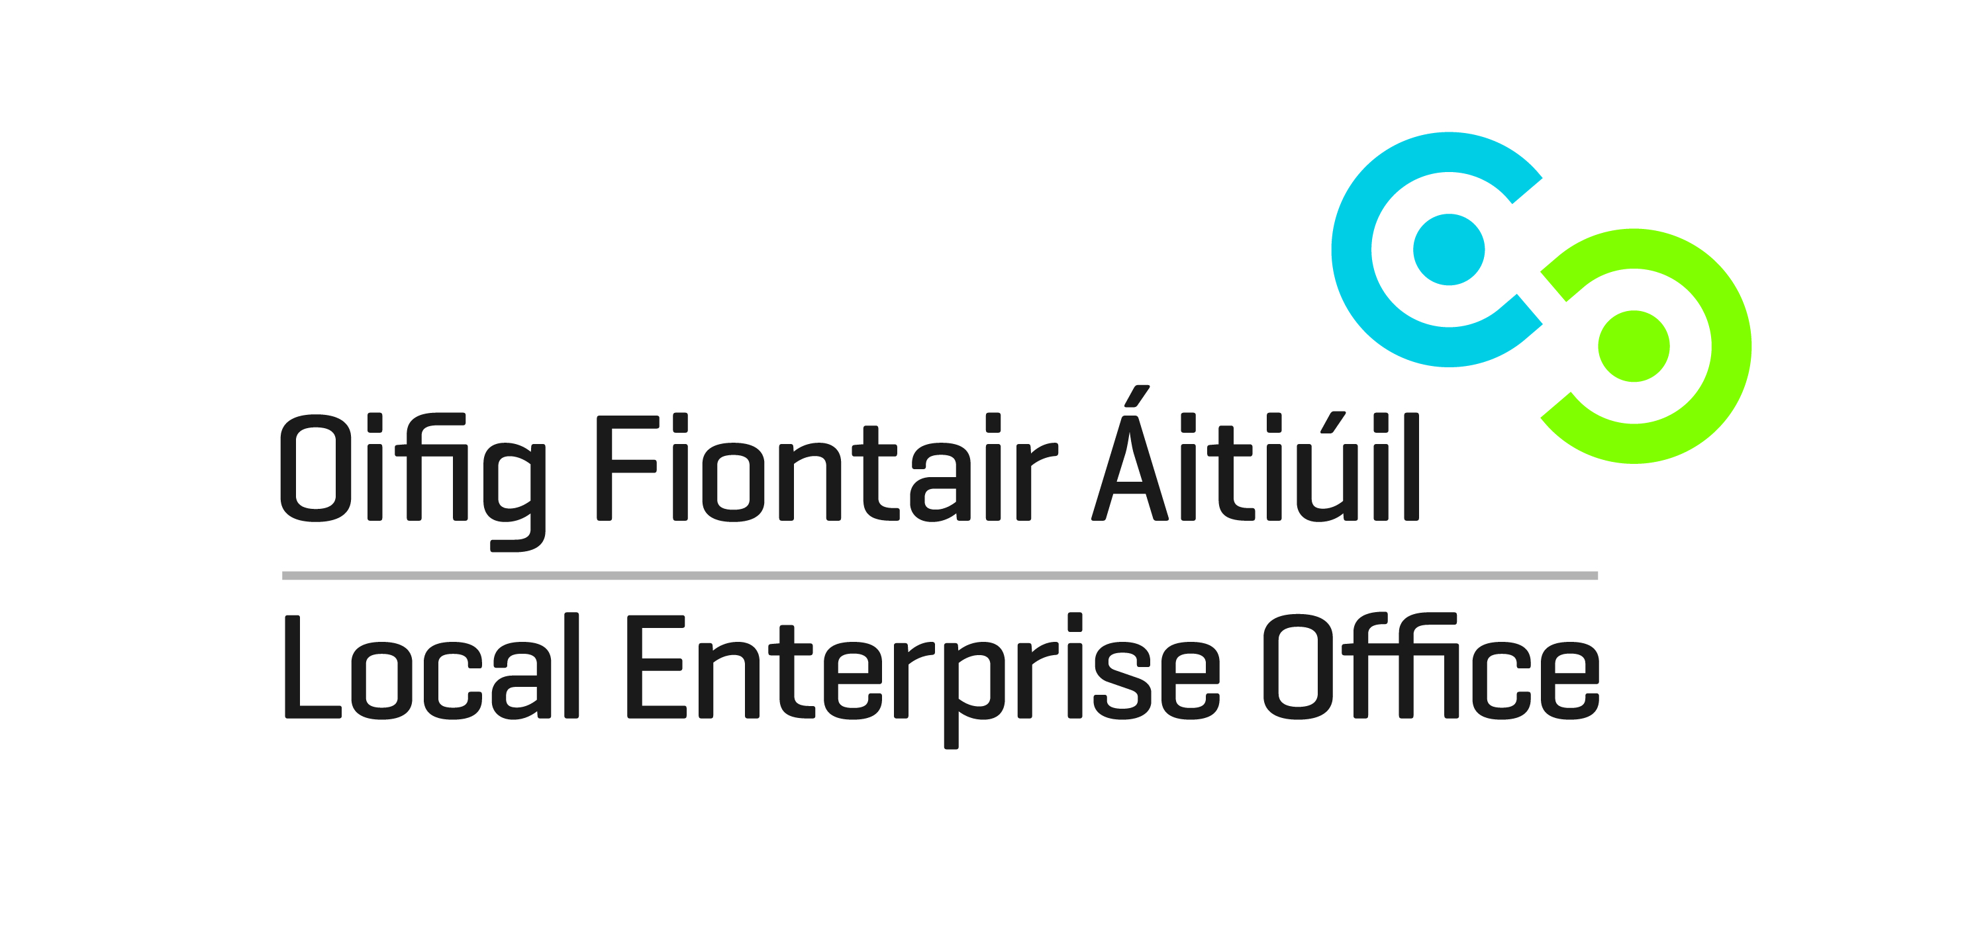
Invitation to Tender: Local Enterprise Office, Cork City, Mentor Panel.
The Local Enterprise Office (LEO) Cork City has the primary function of promoting enterprise and assisting the development of micro-businesses (businesses employing 1-10 employees) at local level. LEO supports include financial assistance (subject to eligibility), business advice, management development training, business to business networking and mentoring.
The Mentor Programme is designed to match up the knowledge, skills, insights and entrepreneurial capability of experienced business practitioners, with managers/owners of small businesses who need practical and strategic one to one advice and guidance.
The Local Enterprise Office, Cork City would now like to invite experienced and qualified Business Mentors to tender for inclusion on our mentor panel. This is not an application for a position of employment. Successful applicants will engage with LEO, Cork City as contractors for the supply of services.
The panel will be established for a 2-year period and during that time mentors will be selected from the panel for client mentoring assignments. Applications are invited from mentors with appropriate skills and experience who wish to be included in the LEO, Cork City mentor panel. Selection criteria apply as outlined in this document and not all applicants may be awarded a place on the panel.
Role/Purpose:
The role of the mentor is to share wisdom gained from experience and learning. They help the clients explore their goals and ideas for the future and help them realistically appraise their current situation. As plans develop the role is to challenge and support the execution of the client’s plans and to assist them keep track of their objectives.
Mentors are not encouraged to solve the problems for the client; rather to help clients develop the capability to solve their own problems. Mentors do not carry out the work on behalf of the client but can be a source of guidance and advice for them. The mentor may offer advice and opinion, but the mentor is not a consultant. Responsibility for decision-making rests solely with the client.

How the Mentor Programme Works:
Clients seeking a mentor complete a mentoring application form, informing their Local Enterprise Office of their specific mentoring need. Each request for a mentor from a client will be dealt with on an individual basis.
The selection of the mentor will be made by the LEO, Cork City based on the type of mentoring required by the client/company and experience and expertise of the various mentors on their panel, to select the most suitable mentor available for the particular project. Where more than one expert mentor is identified as suitable, work will be allocated on a rotation selection basis.
Should assistance be required in more than one field of expertise, one or more mentors may be assigned to the client/company. However, the combined total number of mentor visits must not exceed that agreed.
During the mentor visits, the mentor will help the client/company to develop by advising and mentoring, helping to identify areas for improvement and assisting in developing an action plan and offering guidance in implementing such a plan.
The mentoring service is a professionally delivered service for which a payment at a maximum pro rata rate of €175 per visit (€58 approx per hour) lasting up to 3 hours excluding travel time shall be available to mentors for each visit related to an assignment. This rate is set nationally by Enterprise Ireland.
Each consultation/session is considered as being one mentor visit and the length of each visit will be up to 3 hours duration. The mentor shall provide the Local Enterprise Office with a typed report after each mentoring visit.
The Local Enterprise Office, Cork City prohibits mentors from serving simultaneously as a mentor and as a paid consultant to a client/company.

Experience Required: The mentor will possess some or all of the following: -
- At least three years experience working in/or with micro-enterprise.
- Relevant managerial experience.
- Relevant experience working in an area where particular professional or technical skills may have been developed that are transferable to micro-enterprise.
- Previous experience of delivering mentoring assignments to micro-enterprise clients.
- Good knowledge of the business environment in Ireland, particularly around the supports available for the development of the micro-enterprise sector.

Panel Requirements & Panel Duration:
- LEO Cork City will form a panel of mentors who will be required to take on mentor assignments and be available for other assignments involving LEO, Cork City activity.
- Applicants must provide evidence of professional indemnity insurance and a valid Irish Tax Clearance Certificate when requested.
- The panel will be established for a 2-year period subject to funding being available. Successful panel members will need to update their CVs/profiles annually should there be any changes to same. Mentors will be retained on the panel for the 2-year period, subject to satisfactory performance and professional behaviour. Should the LEO, Cork City identify a gap in expertise in the panel during the 2-year period, mentors with the required expertise may be invited to apply for consideration for inclusion in the panel.
- Individual mentor performance will be monitored over the term of the contract and quality of service will be the main criteria for measuring performance. The successful tenderer will ensure an excellent quality of service, which will be measured by client satisfaction rankings and adherence to a Code of Conduct.
- Before the conclusion of the 2-year term, a review will take place which will examine current mentoring procedures and the performance of mentors on the panel. Mentors will automatically be included on the subsequent panel, unless there are grounds for their removal based on performance evaluation.
- Note: each successful applicant will be provided with the Local Enterprise Office, Cork City mentor manual and a Code of Conduct document.

Application Details:
Tenders by post (3 hard copies and NO BINDING/FOLDERS PLEASE) no later than 4pm on UThursday February 25th 2016 to:
Ita Murphy
Local Enterprise Office, Cork City,
Cork City Council, City Hall, Anglesea Street, Cork. T12 T997
Tenders must include completed application form (Typed) and Applicant’s CV
Enquiries to Ita Murphy: T: 021 4961828 / ita_murphy@leo.corkcity.ie
(Please include an email contact on the outside of the envelope and mark the envelope ‘Mentor Panel Tender’ so that we can acknowledge receipt).
Note:
- All applicants will be treated equally and must submit the requested documents as part of the tender application, regardless of what documents LEO, Cork City may already have on file.
- LEO, Cork City accepts no responsibility for documents arriving after the closing date and time for submissions and late submissions will not be assessed.

UApplication Form
ULocal Enterprise Office, Cork City Mentor Panel
Mentor Details:
NAME
BUSINESS NAME
ADDRESS
TELEPHONE No.
MOBILE No.
FAX No.
EMAIL
WEBSITE
COMPANY REGISTRATION No. (if applicable)
VAT REGISTRATION No. (If applicable)

Qualification Details:
Academic Qualifications | Award  (e.g. Diploma, Degree, Masters, PhD, MBA etc) | Date Awarded
Areas of Expertise:
Please select (tick) a maximum of 6 competencies below and indicate under the ‘Experience in selected Competencies’ further down in this document, samples of recent work relevant to the proposed mentoring services for the competencies that you tick below.
Accounting Software |  | Legal
Accounting/Bookkeeping |  | Market Research
Branding |  | Marketing
Business Planning |  | Negotiation Skills
Costing/Pricing |  | Networking
Customer Care |  | Presentation Skills
Digital Marketing |  | Problem Solving
Distribution |  | Product Design
Employee Retention |  | Production
Environmental Management Systems |  | Project Management
Exporting |  | Raising Finance
Family Business |  | Sales
Financial Management |  | Social Media for Business
Food Hygine/Food Regulation Compliance |  | Strategic Planning
Franchising |  | Taxation/VAT
Human resources |  | Tendering/Procurement
Intellectual Property |  | Time Management
Interviewing & Recruitment |  | Web Optimisation
Leadership Skills
Other (please detail any other areas of expertise not included in above)

Sector Specific Expertise: (Note this section will not be scored – for information purposes only)
Business Services |  | Financial Services
Clothing/Fashion |  | Food Sector
Communication, Media & Entertainment Services |  | Manufacturing
Craft/Design |  | Medical Devices
Customer Services |  | Online Trading/Ecommerce
Digital Sector |  | Packaging Manufacturing
Education |  | Retail/Hospitality
Electronics |  | Software/IT
Engineering |  | Tourism
Environment/Green Technologies |  | E-commerce
Other (please detail any other sector specific area of expertise not included in above)

Previous Experience:
Applicants must demonstrate that they have successfully delivered business mentoring services/training and development services in organisations of a comparable scale and complexity to LEO, Cork City. Evidence must be provided of the successful delivery of three mentoring sessions within the previous five years.
Date | Contracting Organisation | Details of contact person in contracting organisation
 |  | Name
 |  | Position
 |  | Phone
 |  | Email
Comprehensive details of contract / service provided demonstrating comparability with subject matter of panel in question.

Date | Contracting Organisation | Details of contact person in contracting organisation
 |  | Name
 |  | Position
 |  | Phone
 |  | Email
Comprehensive details of contract / service provided demonstrating comparability with subject matter of panel in question.
Date | Contracting Organisation | Details of contact person in contracting organisation
 |  | Name
 |  | Position
 |  | Phone
 |  | Email
Comprehensive details of contract / service provided demonstrating comparability with subject matter of panel in question.

Experience in selected Competencies:
Competency | Justify why this is your chosen competency. Detail your experience/qualifications in this competency.
Optional Voluntary Educational Support:
Please indicate your willingness to partake in a voluntary education panel for the Cork City Schools Enterprise Programme i.e. activities include in-schools talks, trade fair, judging competitions/events, other educational activities.
YES
NO

Please provide details of two referees:
Referee 1
Name:
Address:
Phone:
Email:

Referee 2
Name:
Address:
Phone:
Email:

Rates offered and services required: (Please tick services you are interested in delivering)

Type of Mentoring and experience required | Rates | Tick this box if you are interested in providing this service
LEO, Cork City General Mentoring Programme  Generally 9 hours are allocated to a client to be spread over 3 mentor sessions. | € 58 per hour.  This can include phone and email correspondence undertaken between face-to-face meetings.  Note: mileage cannot be charged for, as all assignments take place in the Cork City area.
Business Advice Clinic Days  Our Business Advice Clinics provide our clients with one to one business advice. 6 client meetings are held over the course of a Business Advice Clinic day.  We require a panel of approx. 6 mentors with broad business skills and experience, excellent communication skills, understanding of financial planning and financial accounting, and ability to deal with a broad range of business types and stages from a variety of sectors. Applicants will be assessed for competencies required to provide this service through their application form and CV.  Applicants interested in providing this service must have the flexibility to be available for a number of full-days throughout the year. | € 58 per hour. 6 client meetings during a business advice clinic day. Current day fee is € 435 to cover 6 –one-hour sessions with clients and including breaks.
Microfinance Ireland Applicant Mentoring  The Local Enterprise Offices process applications for MFI loans on behalf of clients and clients often require assistance in the preparation of their applications, in particular in relation to their business plan and financial projections.  We require a panel of 2-3 mentors with extensive knowledge of the requirements of lending institutions, and the required financial training/qualifications/experience to enable them to assist with the preparation of financial projections and business plans.  Applicants will be assessed for competencies required to provide this service through their application form and CV. | € 58 per hour up to a maximum of 4-hours per client.

Declaration:
 | Yes | No
1. Do any trading/consulting restrictions apply to you?

I declare that, to the best of my knowledge, the facts are true and accurate and will form the basis of my business relationship with the Local Enterprise Office, Cork City or any of its partner organisations. I further declare that I am free from any commercial agreements or considerations which might in any way affect the impartiality of any judgements or recommendations relating to client development projects, unless admitted in writing prior to carrying out any work being supported through Local Enterprise Office, Cork City.

Signed
Name (Block Capitals)
Date

Please ensure your application is typed and completed in full.

Please forward 3 signed hard copies of the application form along with 3 copies of your CV
(NO BINDING/FOLDERS PLEASE) no later than 4pm on UThursday February 25th 2016 to:
Ita Murphy
Local Enterprise Office, Cork City,
Cork City Council, City Hall, Anglesea Street, Cork. T12 T997
Enquiries to Ita Murphy: T: 021 4961828 / ita_murphy@leo.corkcity.ie
(Please include an email/phone contact on the outside of the envelope and mark the Envelope ‘Mentor Panel Tender’ so that we can acknowledge receipt).

Assessment Criteria:

- Applications will be assessed and mentors selected on the basis of the information submitted in response to the call for tender under the criteria below. Applicants must achieve the minimum score for each individual qualitative criterion for consideration.
- All applicants must complete and submit all required documentation by the closing date to be considered for the panel, even if LEO, Cork City already has documentation on file or has used the applicant’s services as a mentor previously.

Mentor Recruitment Evaluation Form:
Award Criteria | Qualifications | Mentoring  Competences | Work  Experience | CEB Experience/  Other state agencies | Total  Score
Percentage Weighting | 20% | 30% | 25% | 25% | 100%
Base Score | 40 | 60 | 50 | 50
Multiplier  0= no evidence or info;  1=poor;  2=average,  3=good,  4=very good, 5=excellent |  |  |  |  | Max  Score
Maximum Score | 200 | 300 | 250 | 250 | 1000
Name/  Company  Name |  |  |  |  | Total  Score | Rank

