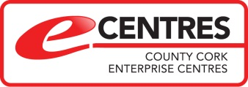

Profile of eCentres Supported
by Cork County Council

BUSINESS GROWTH ZONES

The Economic Development, Enterprise and Tourism Directorate of Cork County Council has responsibility for development of the industrial and commercial infrastructure of County Cork, including business parks, industrial sites, eCentres and incubator units. Comprising of a total of 13 units across the county, these developments were re-branded ‘Business Growth Zone’s in June, 2018, to signify the critical role the Council plays in the Economic Development of the County and give a uniform design to signage at the Council’s business parks and units.

eCENTRES INITIATIVE

Under the branding of the Business Growth Zones, the eCentres Initiative is a network of Community Enterprise Centres which were established by Cork County Council in partnership with local business organisations and state enterprise agencies, to support start-ups, entrepreneurs and remote workers among others, in order to provide dedicated co-working facilities such as hot-desking, offices, training centres, conference and meeting facilities and other services to support businesses and communities in the Cork region.

There are currently 9 eCentres throughout Cork County, namely Bandon, Bantry, Bere Island, Charleville, Fermoy, Macroom, Mizen, Skibbereen and Youghal. In most cases, an eCentre would consist of a ‘hot desk’ area which is called a ‘COCOON’, a meeting/training /conference room and a break-out area for people to network and make contacts.

While Cork County Council manages and owns 2 of these units, the other 7 units are owned by local and not for profit community groups, having received funding from Cork County Council’s Economic Development Fund (EDF) to fit out the premises with ICT infrastructure and the branded eCentre furnishing. These eCentres remain locally owned, but are part of a supportive network of such eCentres throughout County Cork, in partnership with Cork County Council and state enterprise agencies.

LEVELS OF SUPPORT BY THE COUNCIL & OPERATIONAL STRUCTURE OF eCENTRES

Of the 9 eCentres, the following 2 are owned and operated by Cork County Council:

- eBantry
- eFermoy

The following centres are supported by Cork County Council and managed by local community groups:

- Bandon
- Bere Island
- Charleville
- Macroom
- Mizen
- Skibbereen (Ludgate Hub)
- Youghal

Cork County Council has also part-funded development of 2 Community Enterprise Centres in the County and continues to provide support to the centres:

- Mitchelstown Community Enterprise Centre
- Brookpark Community Enterprise Centre (Dunmanway)

For the purposes of this report, data will focus on the 9 eCentres and 2 Community Enterprise Centres, as named above. Some of the analysis will refer to other industrial units within Cork County Council’s network of Business Growth Zones, where stated.

PHOTOS OF eCENTRE FACILITIES

Hot Desks

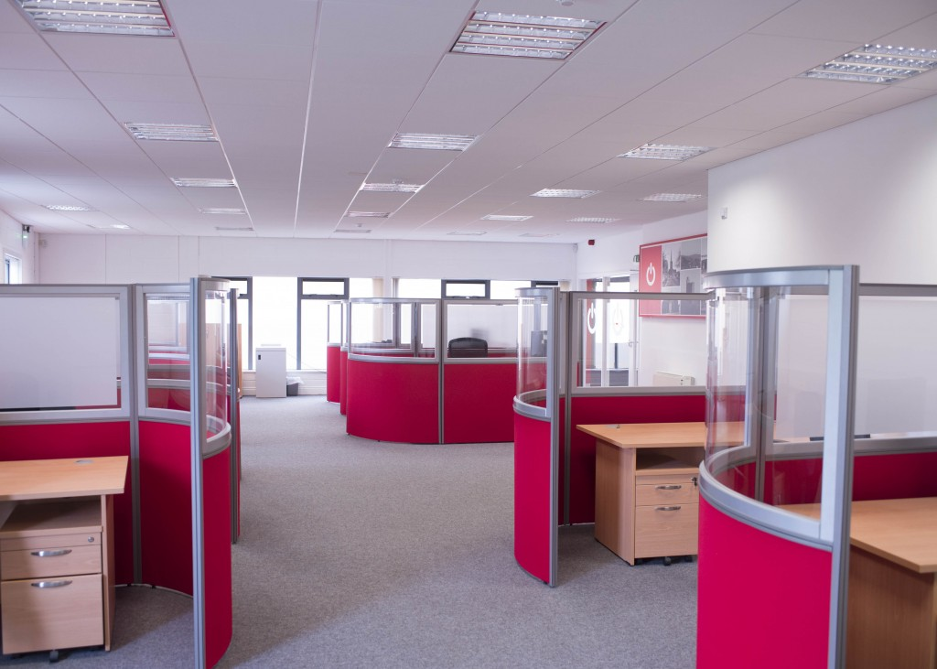

Office Space

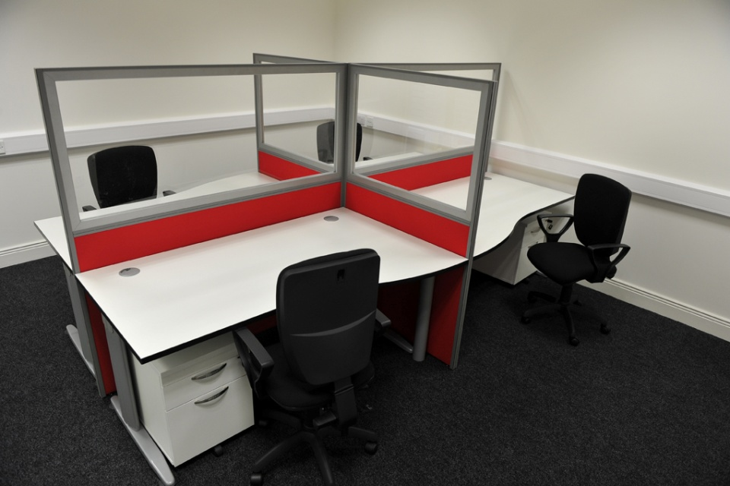

Meeting & Training Space

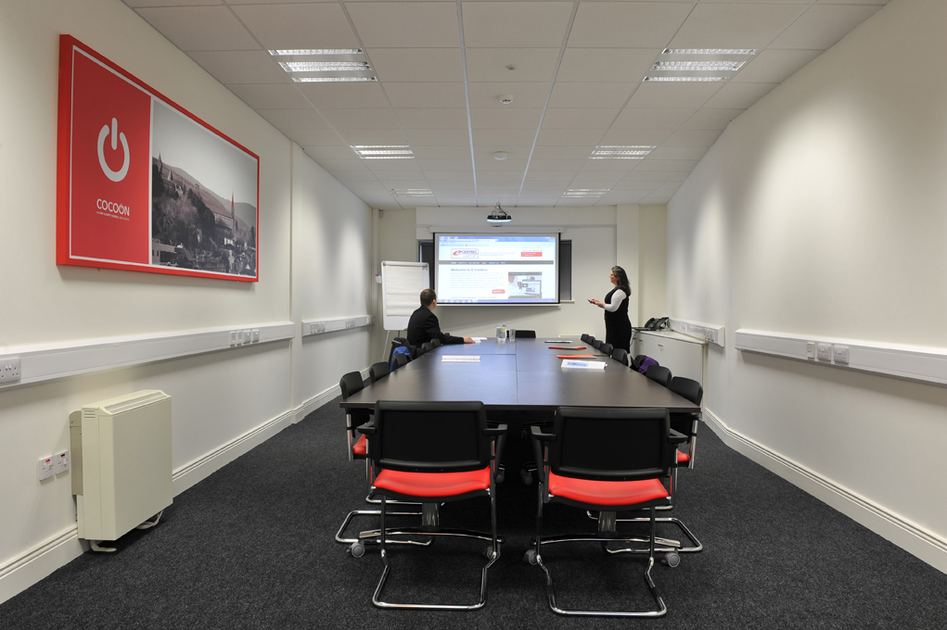

CURRENT eCENTRE FACILITIES

Centre | No. of Offices | No. of Hot Desks | Occupancy Rate of Offices | Occupancy Rate of Hot Desks | Meeting / Conference Room
BANDON | N/A | 6 | N/A | 6 out of 6 | Yes
BANTRY | 1 | 6 | 1 out of 1 | 2 out of 8 | Yes
BERE ISLAND | N/A | 2 | N/A | No tenants at present | No
CHARLEVILLE | N/A | 6 | N/A | 5 out of 6 | No
FERMOY | 5 | 10 | 1 | 5 | Yes
MACROOM | 9 | 6 | 9 out of 9 | 6 out of 6 | Yes
MIZEN | N/A | 5 hotdesks usually operated on a seasonal basis | N/A | 3 out of 5 | No
LUDGATE | 4 private offices and a large open-plan office area with 21 desks | 9 | 4 private offices occupied and 18 out of 21 co-working desks | 3 out of 9 | Google Hangouts room, Boardroom & Workshop room which seats up to 50 people
YOUGHAL | 10 offices & 4art studios | No fixed hot desks, training room being used 2 days a week as makeshift hotdesk | 10 out of 10 | 100% | Training room & separate Boardroom

OCCUPANCY RATES OF eCENTRES

As outlined in the table above, there are a number of centres with high and even full occupancy rates. Of note, Macroom-E and Youghal eCentres are both fully occupied, with all offices and hotdesks currently full, and each of the artist studios occupied in Youghal. eCharleville, which operates on a hotdesk only basis, currently has 5 out of 6 desks occupied. The Ludgate Hub in Skibbereen currently reports a high occupancy rate and is renowned for the success of the centre. Bere Island eCentre does not currently have any tenants occupying the 2 hotdesks available at the centre. Management of this eCentre have advised that they usually only have tenants during the summer season primarily with holidaymakers. Owing to the remote Island location of the eCentre, they find it difficult to market the service and bring in clients outside of peak season. Similarly, eMizen tends to get clients during the summer season, when visitors from overseas may require use of a hotdesk for work. Management of the centre have advised that there are currently 3 out of 5 hotdesks occupied. One of the current occupants is a local travel business, who uses the service throughout the year (as needed), while the other 2 are short-term tenants who were using hotdesks during the October to November mid-term Break.

CURRENT FACILITIES IN CCC SUPPORTED COMMUNITY ENTERPRISE CENTRES

Centre | No. of Offices | No. of Hot Desks | Occupancy Rate of Offices | Occupancy Rate of Hot Desks | Meeting / Conference Room
MITCHELSTOWN COMMUNITY ENTERPRISE CENTRE | 11 | Hotdesks are currently being added as needed to vacant rooms | 9 out of 11 | 3 | Yes - 2 rooms available
BROOKPARK COMMUNITY ENTERPRISE CENTRE | 4 | 7 | 2 | 3 | Yes

OCCUPANCY RATES OF COMMUNITY ENTERPRISE CENTRES

Mitchelstown Community Centre, which has 9 out of 11 offices occupied and is currently adding hotdesks to vacant rooms (as required), is performing strongly, which highlights the potential for success in Community Enterprise Centres. Having officially launched in 2017, the centre has managed to leverage its accessible location on the Dublin Road to attract tenants and is hoping to expand further. The Centre’s large building has a number of unoccupied rooms which could be developed into additional offices and hotdesks. A URDF application was submitted by Cork County Council on behalf of Mitchelstown Community Forum CLF in September 2018, to receive financial support to develop the operation further, expand available office space and enhance amenities in the building. Brookpark Community Enterprise Centre, located in Dunmanway, is a relatively new development, having been launched in June, 2018, which is reflected by the low occupancy rate. The Centre is equipped with 4 offices, 7 hotdesks, conference facilities and a boardroom. Management hope to raise awareness of the Centre in the coming months and thereby increase occupancy.

USE OF TRAINING / MEETING ROOMS

6 of the 9 eCentres and both Community Enterprise Centres have Training / Meeting Rooms equipped with a/v equipment. These provide an additional stream of revenue for the Centres, with regular bookings from organisations such as Turas Nua, Local Enterprise Offices, Jump Juice etc. While data isn’t currently available which details the extent of use / bookings for this aspect of eCentres / Community Enterprise Centres, it is an area which could benefit from further analysis when considering future marketing of the Centres. In particular, the competitive rates compared to Meeting Room rates in hotels and conference centres could be positioned in marketing activity to boost bookings for the hosting of events etc, which not only has cost saving benefits for the organisations involved, but also presents opportunity to showcase the facilities available in eCentres. The following is an example of the costs associated with use of a training room:

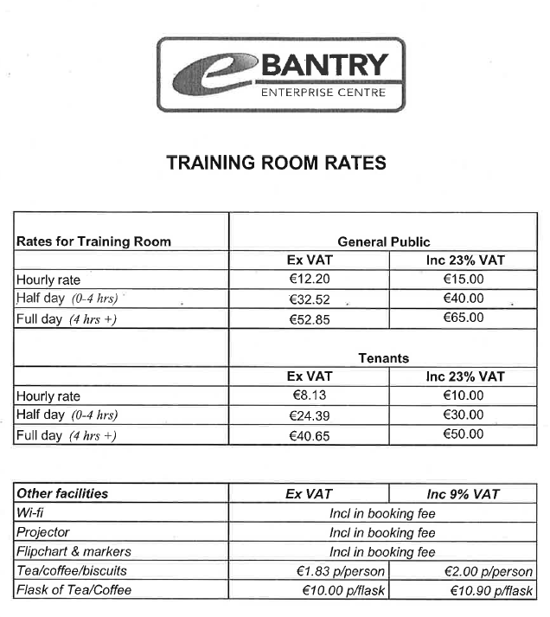
TENANTS’ STAGES OF BUSINESS

According to data collected from eCentres and Community Enterprise Centres, the following is a breakdown of start-ups vs established businesses utilising the eCentres and Community Enterprise Centres. While it wasn’t possible to identify the extent or length of establishment of the established businesses, feedback from the centres suggests Established businesses hold a majority share, as follows:

OCCUPANTS OF eCENTRES:

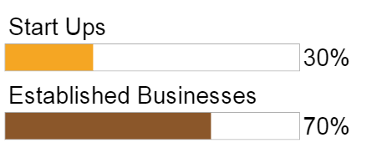

OCCUPANTS OF COMMUNITY ENTREPRISE CENTRES:
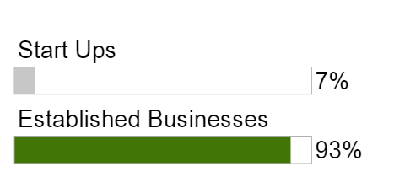
This data draws attention to the value of eCentres and Community Enterprise Centres to Established Businesses. It must be noted that 13 of the total 25 Start-Up businesses operating from eCentres are tenants of Youghal eCentre, otherwise Centres across the board seem to house a large majority of Established businesses. This highlights a marketing opportunity to target Start Ups, who are often considered the ideal target market for this kind of service. A more detailed breakdown is available in the table below:

Centre Name | No of Start-Ups | No of Established Businesses | Majority Share %
Bandon | 3 | 5 | 62.5% Established
Bantry | 1 | 3 | 75% Established
Bere Island | No current tenants | No current tenants | N/A
Charleville | 1 | 4 | 80% Established
Fermoy | 1 | 5 | 80% Established
Macroom | 0 | 5 | 100% Established
Mizen | 0 | 1 | 100% Established
Skibbereen (Ludgate) | 5 | 16 | 76% Established
Youghal | 13 | 4 | 76.4% Start-Ups
Brookpark Community Enterprise Centre | 1 | 2 | 67% Established
Mitchelstown Community Enterprise Centre | 0 | 11 | 100% Established
Total | 25 | 56
SECTORS REPRESENTED IN eCENTRES & ENTERPRISE CENTRES

The following is a breakdown of the industry sectors currently occupying office / hotdesk space in eCentres across Cork County and the two Community Enterprise Centres supported by Cork County Council. Data has been collected via correspondence with management of each centre.

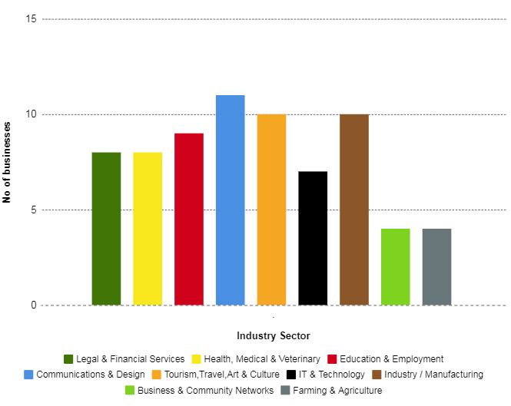

According to this data, the centres are largely occupied by businesses from the service industries, suggesting that eCentres / Community Enterprise Centres are particularly suitable for companies who deliver services. For the purpose of this analysis, the main services present have been broken down to represent the variety of services operating from the supported eCentres and Community Enterprise Centres. Figures suggest that the largest category represented is Communications and Design, with 11 businesses in this area currently occupying desk space in the centres. This includes various media, marketing and design companies. Following this, it is noted that 10 businesses in the areas of Tourism, Travel Art & Culture are tenants, while there are also 10 businesses renting office space who work in Industry or Manufacturing. The eCentre in Youghal accounts for 5 of the Art businesses, having 5 desks occupied by artists in the studios of their eCentre, while desk-occupants involved in Industry / Manufacturing companies are from businesses that produce aviation and electrical products, among others. The areas with the lowest representation throughout Enterprise and eCentres in Cork are those in Farming & Agriculture and Business & Community Networks.

SECTORS REPRESENTED IN INDUSTRIAL UNITS (BUSINESS GROWTH ZONES)

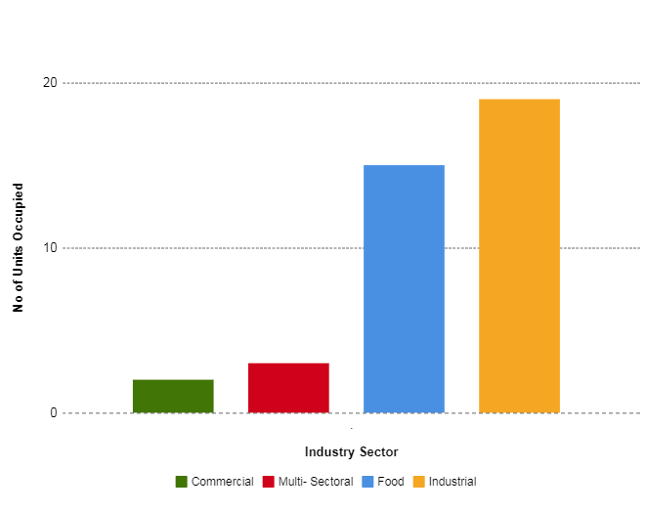

As the chart suggests, Industrial businesses occupy the largest number of units in Cork County Council’s Industrial Units, with a total of 19 units currently being used by Industrial businesses. 15 businesses in the Food Industry are currently tenants in Business Growth Zone industrial units across the County, while there are also some Commercial and Multi-Sectoral businesses. Given the fit-out of these units, which are targeted towards light industry and food businesses (including food incubation units), the findings are as expected.

EXTENT OF MARKETING IN eCENTRES

Bandon - The centre reports that most applicants who approach them have found the service themselves on Google. They currently have an advert with mytown.ie and also promote the service on Facebook.

Bantry – Currently relying on word of mouth and the eCentres website

Bere Island – The service relies primarily on word of mouth. Users are referred to the service through the Bere Island Heritage Centre where the hotdesks are located.

Charleville – The eCentre is also a base for Charleville Chamber of Commerce so it is advertised on the Chamber Facebook, Twitter and LinkedIn pages

Fermoy – It is understood that the eCentre uses local Auctioneer O’ Meara to advertise the service to perspective clients.

Macroom – Most of the centre’s marketing is done through social media on the Macroom-E Facebook page. They also advertise through the Lee Valley Outlook, a local magazine which is free to the public.

Mizen – The Service is promoted through the Mizen eCentre Facebook page. There are also flyers which are distributed. Site management have reported that word of mouth is a major influence among summer visitors to the area. The eCentre has reported that these methods have enabled them to enable 157 clients to date use the hot desks for 2018.

Ludgate – The Company CEO Adrienne Harrington does a large amount of work in promoting Ludgate, she is nearly every week speaking at events all over Ireland, this also involves travel to the UK and Europe. The centre have advised that the work being done by Adrienne in promoting Ludgate is a key factor in attracting people to the hub. Adrienne speaks at many major tech events making vital connections. She also works closely with the Education sector both second and third level promoting the hub. The centre has gained a strong presence on social media, through Twitter, Facebook, LinkedIn and Instagram. They also have a good relationship with the Southern Star newspaper. Word of mouth is reportedly growing and the centre is seeing an increase in repeat business with hot desks.

Youghal – eCentre management have reported that they don’t tend to engage in much marketing – the service is usually promoted via word of mouth. They have an external website http://www.enterpriseyoughal.ie/

EXTENT OF MARKETING IN COMMUNITY ENTERPRISE CENTRES

Mitchelstown – The centre have recently set up a Facebook page and also advertise the service locally with flyers and through community groups

Brookpark – Currently advertising through Twitter, Facebook, LinkedIn and a local estate agent. The company have also released a number of press releases which have been released in local publications such as the Southern Star, West Cork People etc.

FEEDBACK FROM CLIENTS – HOW THEY HEARD OF SERVICE

The following are excerpts from hot desk applications to eFermoy and eBantry, which highlight the need to raise awareness of the service to potential clients.

Question 17 on Hotdesk application form:

Where did you hear about the eFermoy Coccoon facility?

‘Google search. I had no idea it existed. Fantastic Facility’
‘After an online search for a service of this type’

‘I heard about it through the LEO North Cork office in the Start Your Own Business programme’
‘Local Advertising’

FORMER MARKETING OF CCC MANAGED eCENTRES

In 2016, a Cork County Council staff member (who no longer works for the Council) was tasked with responsibility for the marketing and promotion of eBantry and eFermoy. This included advertising in local newspapers, development of promotional material and social media magagement, among other tasks. The following are details of the marketing activities and budget for 2016, as co-ordinated by this member of staff:
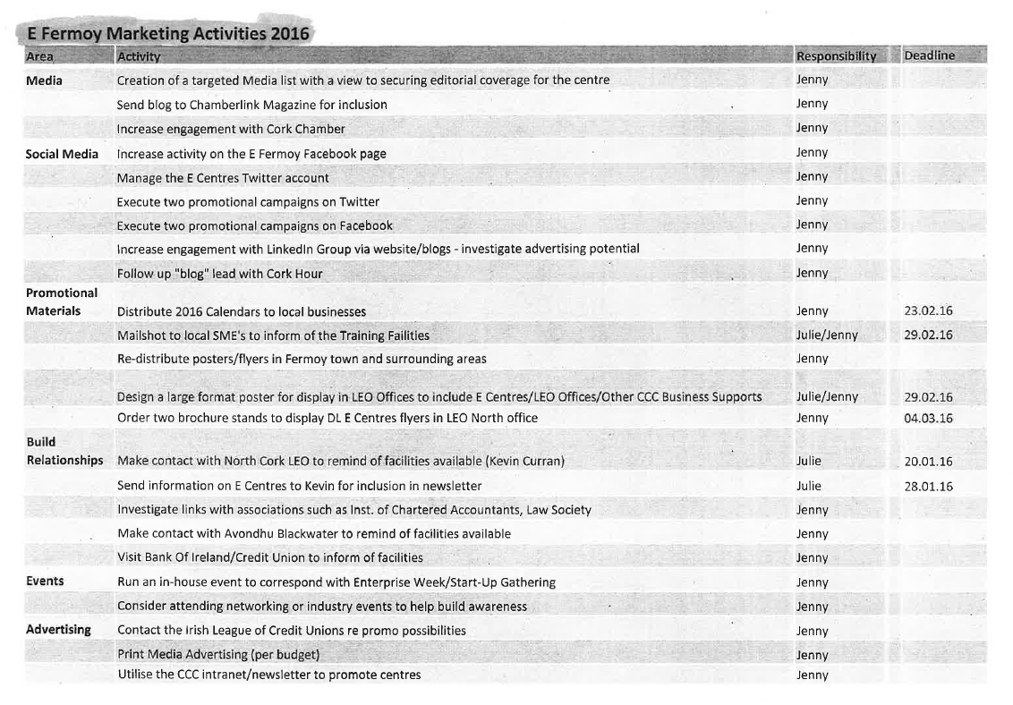

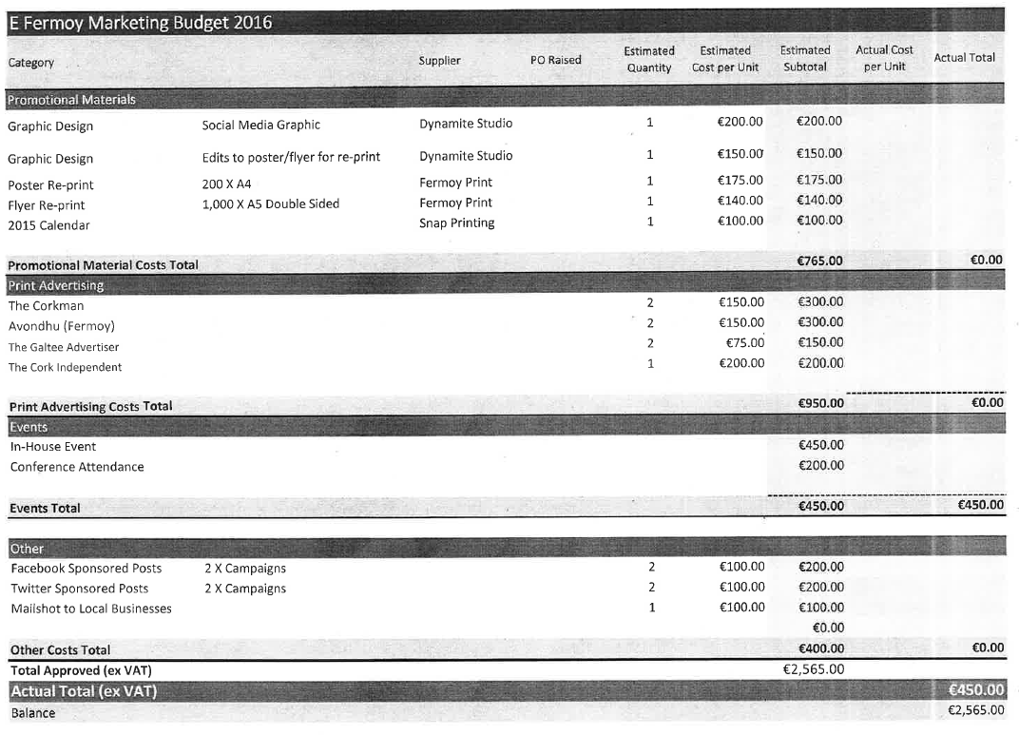

RECOMMENDATION

In light of the data presented in this report, it is evident that eCentres and Community Enterprise Centres alike could benefit from further marketing and promotion. The success of centres such as the Ludgate Hub highlights the strong growth potential for eCentres, which can have many benefits for communities, such as increased entrepreneurship, economic growth, and additional spending in the locality. eCentres are a valuable resource for businesses, offering all the conveniences of a modern office for a fraction of the cost. This enables the sustainability of businesses, allowing companies which avail of the service to focus on aspects such as product and client development. Feedback gathered from hotdesk and office tenants as well as eCentre / Community Management groups makes it apparent that there is inadequate awareness of eCentres across the county. The introduction of a collaborative and multifaceted marketing approach, involving engagement from all stakeholders (including Cork County Council personnel, tenants & management of centres, business groups etc) would be of great benefit to both the eCentre brand and Community Enterprise Centres.

