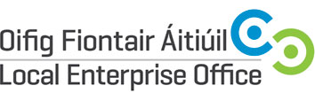 | 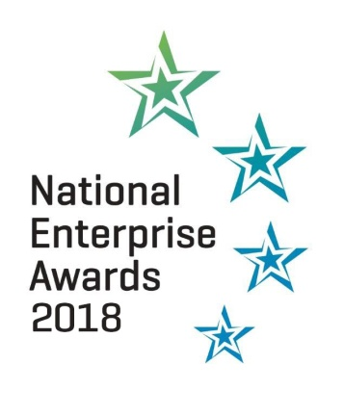
Guidelines for judging criteria and marking system

LEO Name

Promoter

Address
Region

Date Business Established

Telephone

Email

Website

Social Media Details

Business Plan | 20 | Total Marks
- Management capability / staff structure
- Competitiveness
- Growth potential
- Employment potential
- Business strategy
Marketing | 20
- Marketing strategy
- Company’s success in national and export markets
- Growth in sales revenue this year over previous years
- Responsiveness to market trends
Finance | 20
- Financial commitment of the owner
- Profitability of the company
- Strength of the balance sheet
- Net assets of the company
Technology & Innovation | 20
- Use of technology
- Innovation in business e.g. finance, production, marketing, HR etc.
Entrepreneurial Skills of Promoter | 20
- Leadership qualities
- Vision and drive
- Commitment
- Entrepreneurial capability (risk taking etc)

TOTAL (out of 100) ________

Local Enterprise Office

National Enterprise Awards 2018

Competition Guidelines

STAGE 1: The local competition

- The applicants must be current clients of the LEO’s or transferred to
Enterprise Ireland within the last 12 months (i.e. after 31st December, 2016).

- All businesses must have qualified for:
- Measure 1 Financial Support
- LEO Innovation Investment Fund (LIIF) Support
- Ireland’s Best Young Entrepreneur (IBYE) Support
- Technical Assistance for Micro Exporters (TAME) Support
- Trading Online Voucher

Companies that have received support by way of feasibility studies or R&D assistance from other agencies are not excluded.

- All entries must employ ten or less employees employed on a full time equivalent basis.

- Previous County winners are eligible to enter.

- Completed application forms together with a Business Plan, and the most recent financial statements must be submitted for adjudication. Applications without business plan and financial statements will be disqualified.

- Adjudication and prize fund at County level will be the responsibility of the local LEO however consideration should be given to the prize fund available at national level being a maximum of €10,000 for the overall winner.

- Standard judging guidelines and scoring sheet are attached for information.

- Submissions may be made in soft or hard copy for Local adjudication. A short summary text should be provided with their application for PR purposes locally and at national level should they progress to the final.

- All entries for the National Awards Final to be submitted to Diane Gallagher, LEO Galway, Galway County Council, Prospect Hill, Galway no later than noon on Wednesday, 14th March, 2018. Please note that it will not be possible to accept entries after this date.

STAGE 2: The National Final

- Judging to take place (Venue to be confirmed) the weeks beginning 9th April and 16th April 2018. Each finalist will be afforded the opportunity to present an overview of their business by way of PowerPoint to the judging panel and this will be ollowed by an interview. A laptop will be available on the day however finalists are welcome to use their own laptops if they so choose.

- Winners will be announced on the evening of the final on Thursday, 24th May 2018 at
The Round Room, Mansion House, Dublin City. There will be no short-listing this year as per last year’s format.

- Judges decision is final.

- Prize Fund:

From all the finalists, the panel of adjudicators will choose:

- The overall Winner (to receive €10,000)
- The Best Export Business (to receive €5,000)
- The Best Start Up Business (5 years or less) (to receive €5,000)
- Innovation Award (to receive €5,000)
- 8 Regional Winners (to receive €2,000 each)
- Dublin City, Fingal, Dun Laoighre/ Rathdown and South Dublin (4).
- Kildare, Laois, Offaly and Westmeath (4).
- Wicklow, Wexford, Carlow and Kilkenny (4).
- Louth, Meath, Cavan and Monaghan ( 4).
- Donegal, Sligo, Leitrim and Longford (4).
- Galway, Mayo and Roscommon (3).
- Clare, Limerick, Kerry and Tipperary (4).
- Cork City, South Cork, Cork North & West and Waterford (4).

All entries will be judged against the prize categories listed above and regional winners will be acknowledged in addition to the category prizes. Only those companies in existence for less than 5 years will be considered for the Best Start Up Category.

Important Dates:

7th March, 2018 - Local competitions to be complete
9th & 16th April 2018 - National adjudication takes place during these weeks
24th May, 2018 - National Enterprise Awards Event

