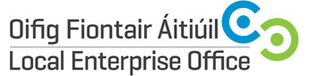

National Ploughing Championships / 18th to 20th September 2018
Expression of Interest
Contact Name:

Company Name and Legal Structure:

Address:
Landline/mobile Telephone:
E-mail Address:
Website Address:
Year the company was established:
Company Description:

Product or Service Description:

Additional information that might be of interest to media? Eg awards/ exports?

Number of employees:
Social media accounts:

Any Special Requirements for NPA?

Please indicate Preferred Briefing Session: | Dublin 20th June 2018 Limerick 27th June 2018

Signature:

__________________________________________
IMPORTANT: Please include product photos or service marketing materials with your application

For Office Use:
LEO Contact Name:
LEO Contact E-mail:

